Introduction to R, vectors, data frames and functions.

R is an open-source, free, statistical software package. Because it’s open source, anyone is allowed to write and upload “packages” for R. These packages contain functions that allow you to do an enormous variety of statistical tests, mathematical functions and graphics. This is wonderful as pretty much anything conceivable has been done by someone else, you just download their package, run the function, and don’t need to re-invent the wheel.

The downside is that because it’s free and open source, it wasn’t built to be aesthetically pleasing, or initially easy to use. There’s no reason to make something pretty if you’re not trying to sell it to someone. As a consequence, the learning curve is initially steep and unforgiving. Don’t get disheartened if you don’t get it immediately, at some point you will get very frustrated, and I expect at least someone in here to start crying, probably me.

Downloading R
- Google “R”, click the “ R project for Statistical Computing” link
- Welcome to the webpage, click the ‘CRAN’ link on the left
- Choose and click the mirror nearest you (probably Canada, SFU)
- Download R for your system (mac, PC, Linux)

Congratulations!! You’ve just acquired the most powerful and versatile stats package in the world.

Note from Ross: DOWNLOAD R STUDIO!
https://www.rstudio.com/products/rstudio/download/
Another note from Ross: DOWNLOAD THE TIDYVERSE!
https://www.tidyverse.org/
(the link above is primarily informative, you can download the packges in R by entering the command: install.packages('tidyverse')
If this command throws you an error, download the most useful packages one at a time:
install.packages('dplyr')
install.packages('tidyr')
install.packages('ggplot2')

Open R
Click and open the program, your first reaction will most likely be overwhelming disappointment and a sense of “is that it?” when you’re presented with…

R version 2.14.0 (2011-10-31)
Copyright (C) 2011 The R Foundation for Statistical Computing
ISBN 3-900051-07-0
Platform: i386-apple-darwin9.8.0/i386 (32-bit)

R is free software and comes with ABSOLUTELY NO WARRANTY.
You are welcome to redistribute it under certain conditions.
Type 'license()' or 'licence()' for distribution details.

Natural language support but running in an English locale

R is a collaborative project with many contributors.
Type 'contributors()' for more information and
'citation()' on how to cite R or R packages in publications.

Type 'demo()' for some demos, 'help()' for on-line help, or
'help.start()' for an HTML browser interface to help.
Type 'q()' to quit R.

[R.app GUI 1.42 (5933) i386-apple-darwin9.8.0]

[Workspace restored from /Users/eddhammill/.RData]
[History restored from /Users/eddhammill/.Rhistory]

>

Yes, that is it. You are currently looking at the “R console”. R is a programming package, you have to “tell it what to do”. Graphical user interfaces (GUIs) are available and are much more like the drop-down menu, point-and-click interface you’re used to, but they tend to be cumbersome and a pain. R works more like a very powerful calculator, you have to actually program the commands into it. As part of this, R has it’s own language, and during the rest of this course we will learn aspects of that language.

Inputting commands into R
There are 2 ways to input into R, these are….
- Type things directly into the console, try this now, type “2*4” and press return, or anything else you fancy. You’ll see it works a bit like a calculator.
- Copy and paste from another window. This is a much better way of using R, and the habit I want you to get into. It means you have a record of everything you’ve done that you can easily edit.

In R, click “File”, and “New Document”. You’ll now be presented with a basic text editor. You can type code into this editor, and easily copy it across to the R Console by pressing “Command + Return” in a Mac, or “Control + R” in a PC.

Just try it with another simple command e.g. 4 times 5, then press enter, you should get…

> 4*5
[1] 20

Believe it or not you just wrote and ran a program. That text file you just wrote in is now technically a piece of software known as a “script”. This one contains a very simple piece of code. Congratulations, you’ve overcome the first step.

Functions and naming things
Not to take away from your achievement, but inputting calculations one at a time into R isn’t really that useful. However, we can name things in R, and then use them again later. For example, say we want a vector of numbers between 1 and 10, and will call it “x.values”. R doesn’t like spaces, so we would input either..

> x.values<-c(1,2,3,4,5,6,7,8,9,10)
Or…
> x.values<-c(1:10)
The “<-“ in R basically means “is”, it’s naming something in a way that R can understand and find later. The “c” means “is a list of..”, and is a very useful command. You can name vectors, data frames, and functions (more on these later). Now type “x.values” and press enter, you should get
> x.values
[1] 1 2 3 4 5 6 7 8 9 10
The [1] at the beginning is just telling us that we’re starting from the beginning (number 1) of the “x.values”. If the list goes over one line, R will give you another number in brackets telling what number the start of that line is.

Naming things in this way is useful as you can use them for other calculations. For example, we could also produce the squares of our x.values by typing the following, the “^” symbol means “to the power of”

> y.values<-x.values^2
> y.values
[1] 1 4 9 16 25 36 49 64 81 100

We now have 2 vectors that R can understand. Of course what we named them wasn’t important, we specified that ourselves. These names are just a way for us to communicate with R.
If we want to plot the two vectors against each other, we can use the inbuilt function plot(). There’s a huge array of functions in R, in each case the function is carried out on whatever is in the parenthesis.
> plot(x.values,y.values)

This will produce a very basic plot of our 2 vectors. Within the plot function are many customisable elements called “arguments”, to find them, we can start by using the incredibly useful “help” function.

> help(plot)

There’s all sorts to play with in there, don’t worry if you don’t understand it all, but as an example, lets make our plot a big red dashed line…

> plot(x.values,y.values,col="red",type="l",lty=3,lwd=3)

If we wanted to combine our 2 vectors into a data frame (similar to an excel spreadsheet in format) we simply use the “data.frame” command.

> x.and.y<-data.frame(x.values,y.values)
> x.and.y
x.values y.values
1 1 1
2 2 4
3 3 9
4 4 16
5 5 25
6 6 36
7 7 49
8 8 64
9 9 81
10 10 100

These data frames are how we will be using most of our own data in R.

As well as the functions built within R, we can make our own. Say for example we wanted to make a function that worked out the square root of something, and then added 2. We would program it, and have to name it something…
> my.function<-function(X){sqrt(X)+2}
The parenthesis () are the thing to which the function is applied to, the curly brackets {} are the actual function. We can then apply this to a number…

> my.function(9)
[1] 5
Or a vector, such as our “x.values” from before.
> my.function(x.values)
[1] 3.000000 3.414214 3.732051 4.000000 4.236068
[6] 4.449490 4.645751 4.828427 5.000000 5.162278

You may need to produce your own functions later down the line in order to perform transformations in data. If you don’t ever need to make one, it’s worth knowing how they’re used as it will give you a better understanding of how they come to be in R.

Task 1… Combining some functions to do a basic test
The function ”rnorm” produces a normal distribution, we can use it to make up simulate some data. For example if we wanted to simulate 10 data points, with a mean of 8 and a standard deviation of 3, we would input

> data.1<-rnorm(n=10,mean=8,sd=3)
> data.1
[1] 11.694046 11.956468 11.174013 6.000238 1.365149
[5] 12.945742 6.089448 10.645392 11.408550 12.508761

Don’t worry if you don’t get the exact same numbers, R is simulating the data and so it will be different each time.

Now, a little test. I want you to produce 2 vectors with rnorm, call one “data.1” and the other “data.2”. The first will be 20 numbers long, have a mean of 15 and a standard deviation of 3. The second will be 15 numbers long, have a mean of 9, and a standard deviation of 2. Have look at your 2 vectors, calculate the means and standard deviations using the functions “mean()” and “sd()”.

Running a t-test
Using “t.test”, see if there is a difference between your vectors (p < 0.05)? If you have trouble with “t.test”, try the help function then ask me. The t.test you are running is asking if there is a difference between the 2 groups.

The t-test tests the null hypothesis (H₀) that there is no difference between the groups

The Alternative hypothesis (H_{a}) is that there is a difference between the groups.

Hints and tips for a better R life.

When producing R scripts, most people like “to annotate” their scripts to keep track of what they’re doing. R doesn’t read anything in a line after a “#” symbol, so you can use this feature to add in notes for future reference.

E.g. in your script could write

x.values<-c(2:15) ## Making a vector of x values

## now to make a list of y.values, these will be the
## x.value^3

y.values<-x.values^3

## Now lets plot that..

plot(x.values,y.values)

You can copy all of that into R in one go, and R will ignore all the stuff behind the #’s. This is very useful later on, and a good habit to get into.

Bringing a spreadsheet from excel to R
Despite how wonderful R is for analysis, the fact remains that actually inputting data into a computer is best done in excel. This is the way in which most of you will be used to inputting data, and will do so in the future. Inputting into R is often a real hurdle and fraught with difficulty for a lot of people. There are multiple ways to achieve it, I’m teaching you the one I most often use. The key point is that the syntax, and file name have to be exactly right. There are a number of other extra things that can also go wrong, don’t worry if it doesn’t work immediately. We’ll go through it step by step.

We’re going to use a small data set I collected in Costa Rica. The place we were staying in was full of scorpions, I decided to see if they were bigger in the kitchen or the bedroom. Each time we caught one in either room, we measured it then threw it the hell outside. The lengths are in “scorpion lengths.xls”. We’re going to import this data, obtain descriptive statistics (mean, standard deviation, standard error) then do a t.test again.

Important point 1 - In excel, save the spreadsheet as a .csv file. Excel asks you if you want to do this in the “save as” menu.

The procedure is now different if you’re using a PC or a Mac, We’ll do PCs first.

PC procedure

In excel, save the file into a folder where you can easily find it, and with a name you’ll recognise, e.g. “R stuff” in Documents, you will save all future data here.

In R, go to “File”, click “Change directory”, find the folder you just saved the file in, and choose this as your directory.

Now input the following line of code

> scorpion.data<-read.csv(“scorpion lengths.csv”,header=TRUE)
“read.csv” is a function like we’ve used before, the “header=TRUE” argument just tells R that the top row is the column names. What we’ve done is brought the data in using the read.csv function, and named it scorpion.data. Type its name to have a look at it.

> scorpion.data
bedroom kitchen
1 74 46
2 67 41
3 85 65
4 56 45
5 75 37
6 71 NA
7 67 NA

Mac procedure
In a Mac the key initial step is to save the file in a folder in your home directory, detailed instructions are below.

In excel, open the scorpion lengths.xls file. Click “save as”, then…..
- On the left of the screen, under “PLACES” click your home directory (the little house).
- Click “New Folder”, call it something like “r stuff”, you will save all future data in here.
- Change the file format to “Comma Separated Values (.csv)
- Save the file

In R, input the following line of code.

> scorpion.data<-read.csv("~/r stuff/scorpion lengths.csv",header=TRUE)
Each of the “/”s means “open this”, and what you just typed in is known as a “file path”. Now just have a look at it to make sure it’s there.
> scorpion.data
bedroom kitchen
1 74 46
2 67 41
3 85 65
4 56 45
5 75 37
6 71 NA
7 67 NA

Everyone back together again! Now run descriptive statistics and do the t-test

The problem is the things we want to test this time aren’t separate vectors as they were before, but columns in a data frame. We need to find away to tell R to look within the data frame. There are two basic ways to do this, each with advantages and disadvantages.

- Telling R directly to look in the data frame

We can do this using “$”, this symbol means tells R to look inside. For example, if we wanted R to show us the lengths of the scorpion from the bedroom, we can type

> scorpion.data$bedroom
[1] 74 67 85 56 75 71 67

That’s telling R that we’re interested in the “bedroom” column, which is inside the “scorpion.data” data frame. You can the use these vectors as we did before for things like “plot” and all the rest of it.

You can now run descriptive statistics on these data by using commands such as

mean() # Calculates the mean of whatever is in the
# brackets

sd() # Calculates the standard deviation of whatever’s in
# the brackets
length() # tells you the “length” of whatever’s in the
# brackets, in this case the number of values we
# have (n)

Task! Use the “$” method to calculate means and standard deviations of the lengths of scorpions from both locations. Then, do a t.test comparing the lengths of the scorpions. If you manage this easily, write a function to calculate the standard error, and run it on the scorpion data.

Generally, I prefer the “$” method, although it requires more typing it avoids attaching data frames together, which can cause problems down the line.

- Using the “attach” function
Rather than selecting columns, we can attach the data frame together, letting R know that we’re interested in using for now.
> attach(scorpion.data) ## Attaching the frame together

We can now run all the same commands as before, but don’t need to use the “$”
> t.test(kitchen,bedroom)
Welch Two Sample t-test

data: kitchen and bedroom
t = -4.0651, df = 7.65, p-value = 0.003964
The issue with this technique is that if we don’t “detach” the data frame afterwards, it languishes around inside R and gets in the way. If we later try to refer to something with the same name as one of our columns, R gets confused and can start to compare the wrong things. This can lead to all kinds of frustration. So always detach when you’ve finished with something.

> detach(scorpion.data) ## Make sure to do this!
When you’ve got to this stage, you’ve made some serious progress. You’ve overcome the first two big challenges of R, talking to it, and getting it to bring in data. At some point down the line, you will struggle to get R to bring in data frames. It happens to everyone, normally when someone’s watching you type. Don’t worry, just work through it slowly, check the command and file path syntax, and it will all fall into place.

Before/after data and paired t-tests
A wonderful feature of t-tests is their ability to deal with paired data, for example looking at before/after the application of a treatment, or looking at the same locations at different times.

For example, saw we wanted to ask whether the population density of Daphnia (a freshwater zooplankton species) differed between the summer and the winter. We could select 10 ponds, take a 1000ml sample of pond water, and count the number of individuals it contained. We may end up with the following data…

daphnia.csv

pond summer winter
1 30 13
2 54 45
3 63 51
4 51 43
5 32 21
6 36 30
7 42 35
8 48 37
9 39 31
10 61 51

We now have repeated measures of our 10 different locations, and could do a t-test as before

t.test(daphnia$summer, daphnia$winter)

Welch Two Sample t-test

data: daphnia$summer and daphnia$winter
t = 1.8354, df = 17.921, p-value = 0.0831

From this is appears as though there’s no difference in Daphnia population sizes between the seasons. However, could we be missing something? Our data here are not technically a random sample, as we’re sampling from the same ponds multiple times, and we’d therefore expect two samples from the same pond to be more similar than two samples from different ponds. Ponds may differ in many important ways, for example some may contain fish that can consume Daphnia, some may contain more food for Daphnia than others. As a consequence, the differences between the ponds are so large, that the variance of the two samples becomes very large. The data does have a natural pairing however (each site was sampled twice), and we can use this pairing as a sort of natural control. What if, instead of asking if there was a difference between the samples, we took the difference between the summer and winter value for each ponds, and see if the overall difference is significantly different from 0. If it is different from 0, then we’re essentially saying there was a difference between the summer and winter sample.

Fortunately, we don’t need to do this by hand, as R can do the whole thing automatically. All we have to do is set the “paired” argument in the t-test to TRUE.

t.test(daphnia$summer, daphnia$winter,paired=TRUE)

Paired t-test

data: daphnia$summer and daphnia$winter
t = 9.9611, df = 9, p-value = 3.696e-06

You can see that now the result is significant. We don’t have as many degrees of freedom as before, as technically we’ve only got half as many data points (1 list of differences, instead of 2 lists of the actual values). Remember though, this technique can only be used when there is a natural pairing to the data.

“Long form” data in R
So far we’ve just looked at comparing 2 lists of data. It is however possible to use a slightly different method. Whenever we’re performing a statistical test, we have at least 2 variables, a response variable (the thing we’re interested in) and a descriptive variable (the thing we want to use to group the data). For example, say we wanted to see if there was a difference in height between men and women, “height” would be our response variable, and “sex” would be our descriptive variable. If we had the data in a data frame named “heights”, which contained 2 columns; “height” – the height in cm, and “sex” – either male or female, overall the data would look like…

height sex
1 186 male
2 179 male
3 168 male
4 190 male
5 183 male
6 175 male
7 169 male
8 176 male
9 162 female
10 159 female
11 162 female
12 143 female
13 142 female
14 157 female
15 152 female

we could perform the following test….

t.test(height~sex,data=height)

This would generate results identical in form to the ones we saw before..

Welch Two Sample t-test

data: height by sex
t = -5.7667, df = 12.377, p-value = 7.909e-05

The “~” inside the t.test literally translates as “by”, so with the command line we’re saying “do a t.test looking at height differentiated by sex”. This method of using the “~” (called a “tilda”) is very common in R, and we shall be using it for the majority of the remaining tests. It is very important as it allows you to perform tests using multiple descriptive variables, and have multiple levels within a variable. But more on that later.

Now try using the “~” method for yourself. Import the dataset “scorpion long” into R, and run the t.test, check you got the same result as when you ran the t.test before. You should do, you’re using the same data, it’s just organised differently.

T-test notes
If you’re interested in how the t-test works, extensive information is available online. Essentially, it uses the following formula

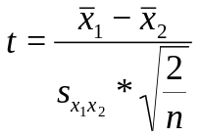

Where the x’s are the means of the 2 samples, s_{x1x2} is the pooled standard deviation, and n is the total number of samples. We also need to know the number of degrees of freedom (the sample size n – 1). We can then look up our value of t with the appropriate number of degrees of freedom in t-tables, and if it is greater than the critical value, we have a significant difference. For example, say we had 20 samples, and found a t value of 5.60, we would look up the critical value (p < 0.05) of t on 19 degrees of freedom (2.093). As ours is bigger, we have a significant difference. We would then report it in the following manner (t₍₁₉₎ = 5.60, p < 0.05). Of course, R does all this for us, and we just need to read the t-value, the degrees of freedom, and the p-value.
Task!
Now you’ve managed to bring in data sets and communicate with R, have a go at doing the following..

- Bring in the data set “bromeliad.xls” (consult the instructions above for all the steps!)
- Make a plot with max.vol on the x-axis, and mosquitoes on the y.
- Perform a t-test to see if the number of mosquitoes differed between plant species (the “species” column in the dataset).

Introduction to ANOVA

We previously looked at using a t-test to ask whether two different groups of data are significantly different from each other. We tested the null hypothesis of no difference between groups. In our case we had scorpion lengths from two different rooms on a research station. However, often we have data from more than two different groups (for example, if we’d found scorpions in the kitchen, bedroom AND bathroom, heaven forbid). In this situation we may want to ask if any of them differ from each other, for this we need a slightly different test, called “the Analysis of Variance”, or ANOVA.

ANOVA is a very powerful, useful and versatile statistical test. It is at the heart of most of the statistics currently used, including (but not limited to) regression, linear modelling, non-linear modelling, mixed effects, MANOVA, analysis of covariance. As a result, you really want to understand it and know how to use it.

The first thing to understand, is what an ANOVA actually tests…

Null hypothesis (H₀) = There are no differences between the groups

Alternative hypothesis (H_{A}) = at least one group is different from one other.

It is important to understand that the alternative hypothesis is not saying ALL groups are different from ALL others, just that at least one is different from one other. For example, if we had 3 groups; A, B, and C the alternative hypothesis (H_{A}) is…. A≠B≠C,
or A≠B B=C but A≠C,
or A≠B A=C C≠B
or A≠B A≠C but B=C
etc…….

In the t-test, the test relied on a t-statistic, which had a number of degrees of freedom (n-1). In the ANOVA, it uses a slightly different statistic, the f-statistic, which has it’s own tables. The number of degrees of freedom are slightly different as well because we have not only the number of samples (n), but also the number of groups (k). We have to take both these into account.

Formally, when we run an ANOVA, our groups are known as our treatment, and each of our groups are formally known as levels of the treatment. The actual ANOVA test calculates an f-statistic, and then looks at whether this value is greater than the critical value of f with the correct treatment degrees of freedom (k-1), and our error degrees of freedom ((n-k)-1). Of course, being wonderful, R does all this for you and you just have to know where each value is, and what it means.

For example, lets take another look at the bromeliad data.

data<-read.csv("~/bromeliads.csv",header=TRUE)
data ### Taking a look at it…

leaf.number diameter max.vol well.vol mosquitoes species location
10 58.5000000 450 45.00000 12 guzmania pitilla
10 63.5000000 900 90.00000 67 guzmania Monte.verde
12 87.0000000 200 16.66667 3 guzmania pitilla
13 113.5000000 875 67.30769 16 guzmania pitilla
13 93.0000000 500 38.46154 35 guzmania Monte.verde
14 60.0000000 450 32.14286 24 guzmania Monte.verde
15 72.0000000 200 13.33333 15 guzmania pitilla
15 80.0000000 1250 83.33333 113 verasia De.salva
16 112.5000000 1250 78.12500 95 verasia Monte.verde
16 96.0000000 1000 62.50000 100 verasia De.salva
16 84.0000000 1000 62.50000 110 verasia De.salva
18 87.5000000 1500 83.33333 102 verasia De.salva
19 74.0000000 750 39.47368 12 guzmania pitilla
20 89.5000000 1140 57.00000 32 guzmania Monte.verde
20 0.5288462 500 25.00000 36 guzmania Monte.verde
21 95.5000000 500 23.80952 3 guzmania pitilla
21 80.0000000 300 14.28571 15 guzmania pitilla
21 85.0000000 625 29.76190 88 verasia Monte.verde
21 135.5000000 3000 142.85714 148 verasia pitilla
22 107.5000000 1500 68.18182 105 verasia De.salva
25 95.0000000 1250 50.00000 83 verasia Monte.verde
25 91.5000000 3000 120.00000 152 verasia pitilla
26 115.0000000 1100 42.30769 121 verasia De.salva
27 84.5000000 750 27.77778 34 guzmania De.salva
27 98.0000000 750 27.77778 38 guzmania Monte.verde
27 87.0000000 1125 41.66667 120 verasia De.salva
34 69.0000000 1500 44.11765 52 guzmania Monte.verde
36 102.5000000 1250 34.72222 100 verasia De.salva
40 94.5000000 500 12.50000 6 guzmania pitilla
42 107.5000000 1250 29.76190 102 verasia De.salva

Last time, we used the column “species” to run a t-test, but say for example we wanted to see if the number of mosquitoes differed between the 3 locations, “De salva”, “pitilla”, and “Monte verde”. We now have to run an ANOVA as we have more than two groups, we do this using the “aov” command in R.

ANOVAs run slightly differently than t-tests, and we have to actually name the test something, we’ll call it “anova.1”. As the data is in long form we have to use the “~”, because we’ve not attached it we also use the “$”. Remember, R won’t read anything after the “#”

anova.1<-aov(data$mosquitoes~data$location) ## test code

When you run the test, it doesn’t automatically give you the output, this is because you’ve just produced the test within R, to look at the results, you need to use the “summary” command..

summary(anova.1)

This should then give you the following ANOVA table…

Df Sum Sq Mean Sq F value Pr(>F)
data$location 2 20923 10462 6.55 0.0048 **
Residuals 27 43124 1597
---
Signif. codes: 0 ‘***’ 0.001 ‘**’ 0.01 ‘*’ 0.05 ‘.’ 0.1 ‘ ’ 1

This contains everything you need to report your result, R has calculated the f-statistic, the p-value, and all the degrees of freedom (Df) for you, and even told you the significance level.

In our case, “data$location” was our treatment, and you can see from the degrees of freedom column the treatment df=2 (remember, treatment degrees of freedom equal number of levels minus one). It has given us our error degrees of freedom (Although R calls these “Residuals”, just to be difficult). So how do we report this, bearing in mind what our original question was; are there differences in mosquito abundance between the locations?

To formally report this, we would write “We reject the null hypothesis of no difference between mosquito abundances among the three locations (f_{(2,27)} = 6.55, p = 0.0048, ANOVA)”. This one sentence conveys all the information we want to get across. Whenever you report the f-statistic you must report the degrees of freedom in the brackets in the following order; treatment df first, then error df.

Post-hoc testing
Although ANOVA is wonderful and allows us to test multiple different groups, it doesn’t actually tell us which groups are different from each other. As this is useful and interesting, we need a way to do it.

DON’T JUST DO A BUNCH OF T-TESTS
We cannot however just do a series of three pairwise t-tests, this is very naughty. With a t-test we’re looking to be 95% confident that there is a difference between the groups, we have a 5% chance of finding a difference when it isn’t there. Essentially, we’ve a 5% chance of being wrong. However, if we run three of tests together, we’re inflating the chance of finding at least one difference because due to probability theory our chances of being wrong at least once is…

1-(95%*95%*95%) = 1-85.7% = 14.3%

This means across our three tests, we have a 14.3% chance of finding at least one significant difference when it doesn’t exist. If we had 4 groups, and did all the pairwise t-tests (6 in total) our chance of being wrong increases to 26.5%, and it gets even worse every time you add another group.

There is a solution, the Tukey test!
The Tukey test is a legitimate post-hoc test we can use to look for all the differences between our groups, it’s conservative, and very commonly used and accepted. In R, it’s also very easy to run, we just use the “TukeyHSD” command on whatever we named our ANOVA test, in our case, “anova.1”

TukeyHSD(anova.1) ### Running a post-hoc Tukey test
This gives the following results table…

Tukey multiple comparisons of means
95% family-wise confidence level

Fit: aov(formula = data$mosquitoes ~ data$location)

$`data$location`
diff lwr upr p adj
Monte.verde-De.salva -45.7 -90.01399 -1.386014 0.0422571
pitilla-De.salva -62.5 -106.81399 -18.186014 0.0045414
pitilla-Monte.verde -16.8 -61.11399 27.513986 0.6202390

Beautiful, just look at it. It’s fitted our model (in the Fit: “aov….” Line) and then given us p-values for all of our location comparisons in the last column of the table. We can now just read these off and report them. We see Monte verde differed from De salva, pitilla differed from De salva, bit Pitilla didn’t differ from Monte verde.

PRESENTING DATA USING “barplot2”

Although the output from the “aov” and “TukeyHSD” commands are very useful for showing where significant differences lie, however simply putting the output into papers isn’t really the best way to present data. There are multiple ways to present data, and a lot of it is down to personal preference, however my favourite is to use barplots of means, with error bars of the standard errors. There are multiple ways to achieve this, I find the most convenient is to use the function “tapply”, and the function “barplot2” in the “gplots” package.

To get this package, we have to download it.

Open R, and click “packages & data”, then click “package installer”, it will ask you to pick a local mirror, choose the one nearest you (probably SFU). Look up the package “gplots”, when it’s found it, click the “install dependencies” box (this downloads all the packages Hmisc needs to make it work) and then press install. In your R-script window, you can now open the package using…

library(gplots)

The package, and all its functions, are now loaded into R.

We can now use these packages to build beautiful barplots.

GETTING THE DESCRIPTIVE STATISTICS FOR THE PLOTS USING tapply

The “apply” family of commands are very useful, we’ll go through “tapply” now, this function can apply a particular command to multiple levels at once. We’ll use it to calculate the mean, standard deviation, sample size, and then standard errors of our

##means
means<-tapply(data$mosquitoes,list(data$location),mean)
means

##Standard deviations
st.dev<-tapply(data$mosquitoes,list(data$location),sd)
st.dev

However, we want standard errors, and standard errors are the standard deviation divided by the square root of the sample size. First, we need to find the sample size

##sample sizes
lengths<-tapply(data$mosquitoes,list(data$location),length)
lengths

##calculating standard errors
st.errors<-st.dev/sqrt(lengths)
st.errors

We now have a list of vectors of data to build the barplot, we’ll make one more list of names to label the plot

names<-c("De Salva","Monte Verde","Pitilla")

We can now (finally!) build our plot. Use the “help” function to understand what all the different arguments within “barplot2” mean.

barplot2(means, plot.ci=TRUE,ci.u=means+st.errors,ci.l=means-st.errors,names.arg=names,space=0,ylab="Mosquitoes")

You should get something that looks like this….
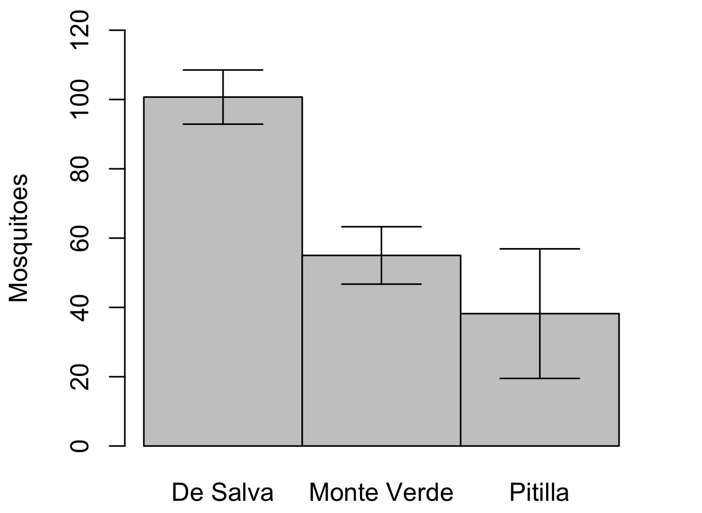
Beautiful!
Multi-way ANOVA
In the previous example we showed how an ANOVA can be used to look for differences between levels of a treatment, but what if we have more than one treatment? In our Bromeliad example we’ve looked at whether the plant species affects the number of mosquitoes (using a t-test), and whether location affects number of species (with an ANOVA). However, these two treatments (plant species and location) are technically 2 different treatments that affect all the plants, we should therefore try and compare their results in one test.

We do this using Multi-way ANOVA, you may see it called “2-way ANOVA”, but as you can use more than 2 different treatments this name doesn’t always make sense.

Whenever we run a multi-way ANOVA, we need to check to see if we have a significant interaction between the explanatory variables. If we have a significant interaction term, it means that the effect of one variable depends on the value of the other.

Running a Multi-way ANOVA is relatively simple, we just include one extra term in our line of code. We will use the same bromeliad data set as before.

data<-read.csv("~/bromeliads.csv",header=TRUE)
anova.2<-aov(data$mosquitoes~data$species*data$location)
## Now to look at the results

In the line of code for the test, we are writing “perform an ANOVA test using mosquito as the response variable, and both location and bromeliad species as explanatory variables.” By using the “*” symbol between the two explanatory variables, we are telling R to include the interaction term, if we did not wish to include the interaction, we replace the “*” with a “+”.

Lets look at the results…

summary(anova.2)
Df Sum Sq Mean Sq F value Pr(>F)
location 2 20923 10462 121.0 2.91e-13 ***
species 1 33286 33286 385.0 2.76e-16 ***
location:species 2 7763 3881 44.9 7.74e-09 ***
Residuals 24 2075 86

In the above test, we can see that R has tested each of the variables, and also the interaction term (location:species). The interaction term is significant, as well as both of the main effects, so what does this mean?

Interaction terms
Interaction terms can be difficult to initially understand, however they are very important. In our above bromeliad example we have a significant interaction term this means the relationship between mosquito density and plant species depends on which location we’re talking about. Lets look at a simple plot of the data.

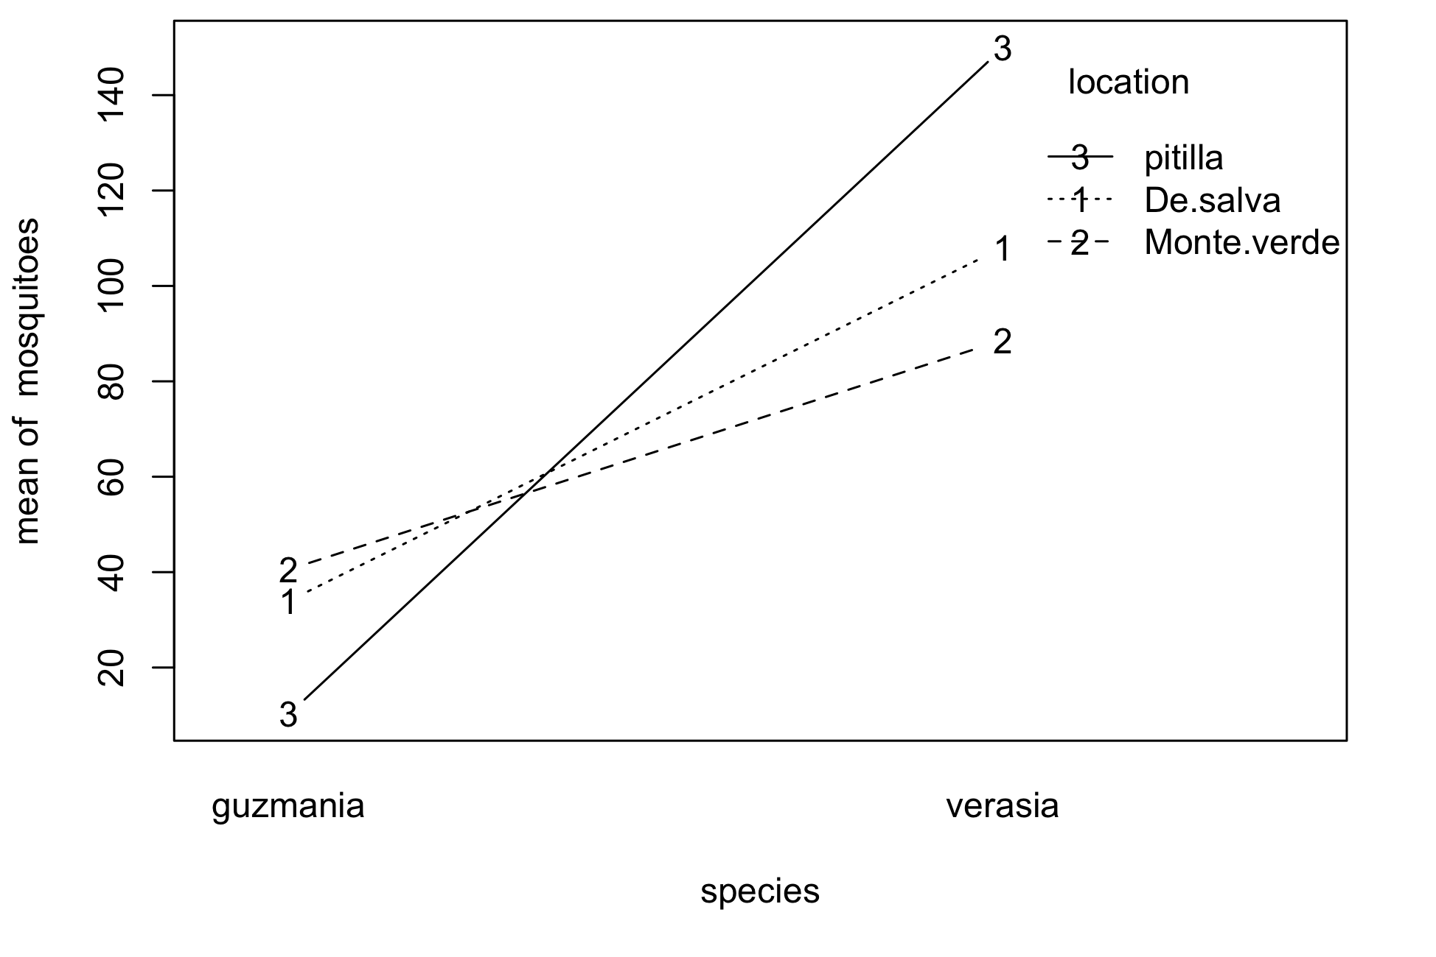
On the x-axis we have the species of plant, and on the y-axis we have the mean mosquito density. The three numbers then give the mean number of mosquitoes in each species of plant, at each location. If we look at Guzmania to begin with, we can see that on average, the most number of mosquitoes were found in plants from Monte Verde, and the least in plants from Pitilla, with De Salva being in the middle. However, if we were to look at verasia plants, we see the pattern is reversed, the highest number of mosquitoes were fount in Pitilla, with the least being in Monte Verde. So if someone were to ask the question of “where would you expect to find the highest density of mosquitoes”, we’d have to ask back “in which species of plant”. You can’t answer the question of where is the highest density without knowing if they’re interested in guzmania or verasia, because the pattern of relative abundance is reversed. Essentially, we can’t say anything about mosquito abundance without referring to location and species. As a result, whenever you find a significant interaction term, when discussing the results you should only really discuss the interaction.

We have a significant interaction whenever we don’t find parallel lines
Say for example we had a situation where the interaction term was not significant, e.g. we had conducted the experiment and this time found the following result..

Df Sum Sq Mean Sq F value Pr(>F)
species 1 572 571.7 7.416e+30 <2e-16 ***
location 2 5375 2687.5 3.486e+31 <2e-16 ***
species:location 2 0 0.0 9.600e-02 0.909
Residuals 24 0 0.0

Here both the main effects are significant, but the interaction term isn’t. So we remove it and run the model again. To remove the interaction, we simply change the “*” for a “+” in the line of code, giving us..

anova.3<-aov(data$mosquitoes~data$species+data$location)
summary(anova.3)

Df Sum Sq Mean Sq F value Pr(>F)
species 1 572 571.7 7.970e+30 <2e-16 ***
location 2 5375 2687.5 3.747e+31 <2e-16 ***
Residuals 26 0 0.0

Whenever you have a non-significant term, you remove it, and then re-run the test before giving the results. Now, we have our two significant main effects, if we again produce a simple plot of the results…

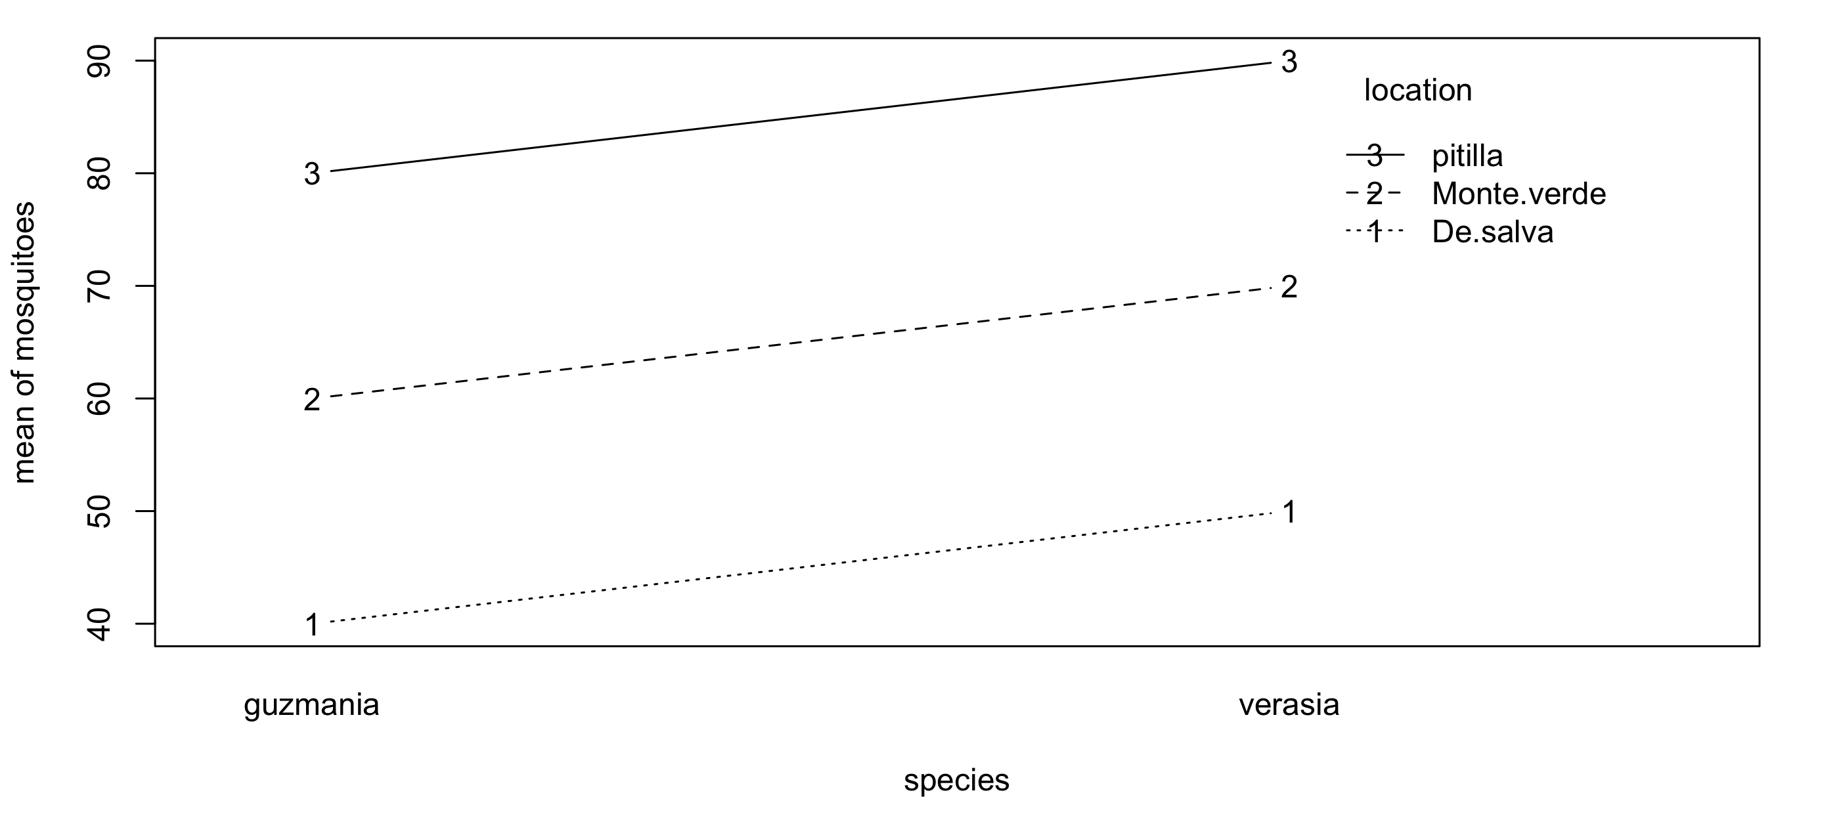
We can now see that the lines are parallel. What this means is that we can discuss the main effects, there are more mosquitoes in verasia plants than in guzmania, and the most mosquitoes are always found in Pitilla, and the least at De Salva. A lack of an interaction means we can describe what the relative effects of different locations are regardless of which species of plant we’re talking about.

TUKEY’s test on multiway ANOVA
We can perform a tukey test when we are performing a multi-way anova, however life is just a little more complex. If we have a significant interaction term, we can only perform the Tukey test on that interaction term. This means we will have a lot of pairwise comparisons. Within the “TukeyHSD” command we have to specify which effect we want to look at. Eg, our significant interaction from anova.2….
anova.2<-aov(data$mosquitoes~data$species*data$location)

Df Sum Sq Mean Sq F value Pr(>F)
location 2 20923 10462 121.0 2.91e-13 ***
species 1 33286 33286 385.0 2.76e-16 ***
location:species 2 7763 3881 44.9 7.74e-09 ***
Residuals 24 2075 86

### Now performing the Tukey

TukeyHSD(anova.2,"data$species:data$location")

Tukey multiple comparisons of means
95% family-wise confidence level

Fit: aov(formula = data$mosquitoes ~ data$species * data$location)

$`data$species:data$location`
diff lwr upr p adj
verasia:De.salva-guzmania:De.salva 74.111111 43.80795 104.4142691 0.0000012
guzmania:Monte.verde-guzmania:De.salva 6.571429 -24.16158 37.3044400 0.9845750
verasia:Monte.verde-guzmania:De.salva 54.666667 21.47122 87.8621130 0.0004246
guzmania:pitilla-guzmania:De.salva -23.750000 -54.24196 6.7419645 0.1930269
verasia:pitilla-guzmania:De.salva 116.000000 80.79091 151.2090878 0.0000000
guzmania:Monte.verde-verasia:De.salva -67.539683 -82.02736 -53.0520020 0.0000000
verasia:Monte.verde-verasia:De.salva -19.444444 -38.60984 -0.2790446 0.0453625
guzmania:pitilla-verasia:De.salva -97.861111 -111.83018 -83.8920455 0.0000000
verasia:pitilla-verasia:De.salva 41.888889 19.41547 64.3623123 0.0000813
verasia:Monte.verde-guzmania:Monte.verde 48.095238 28.25716 67.9333117 0.0000014
guzmania:pitilla-guzmania:Monte.verde -30.321429 -45.19998 -15.4428734 0.0000221
verasia:pitilla-guzmania:Monte.verde 109.428571 86.37881 132.4783300 0.0000000
guzmania:pitilla-verasia:Monte.verde -78.416667 -97.87922 -58.9541111 0.0000000
verasia:pitilla-verasia:Monte.verde 61.333333 35.09003 87.5766379 0.0000025
verasia:pitilla-guzmania:pitilla 139.750000 117.02263 162.4773685 0.0000000

All the possible pairwise comparisons gives us an awful lot of data.
If however we don’t have a significant interaction, as with our data we used to perform anova.3, the situation is much simpler.

anova.3<-aov(data$mosquitoes~data$species+data$location)
summary(anova.3)

Df Sum Sq Mean Sq F value Pr(>F)
species 1 572 571.7 7.970e+30 <2e-16 ***
location 2 5375 2687.5 3.747e+31 <2e-16 ***
Residuals 26 0 0.0

“Species” only has 2 levels, “guzmania” and “verasia”, so to get a significant result these two must be different from each other.
“location” has three levels, “De Salva”, “Monte Verde” and “Pitilla”, so we ca run a Tukey test to see which of them is different from each other

anova.3<-aov(data$mosquitoes~data$species+data$location)
summary(anova.3)

Df Sum Sq Mean Sq F value Pr(>F)
species 1 572 571.7 7.970e+30 <2e-16 ***
location 2 5375 2687.5 3.747e+31 <2e-16 ***
Residuals 26 0 0.0

## Now the Tukey

TukeyHSD(anova.3,"data$location")

Tukey multiple comparisons of means
95% family-wise confidence level

Fit: aov(formula = data$no.int ~ data$species + data$location)

$`data$location`
diff lwr upr p adj
Monte.verde-De.salva 8.201786 6.449143 9.954429 0.0001
pitilla-De.salva 26.718750 24.966107 28.471393 0.0002
pitilla-Monte.verde 18.516964 16.764321 20.269607 0.0001

In this case we can see that the number of mosquitoes is different in each different location.

Stepwise removal of non-significant terms
When ever we do multi-way ANOVAs, we remove non-significant terms one at a time. The general rule is that you run the full model with all interactions first, if the interactions are significant, you leave it there! If they’re not, you remove them one at a time, starting with the one with the most terms in (i.e. a three-way interaction). If none of the interactions are significant, we then start removing none significant main effects, one at a time, re-running the model each time. If one of the interactions is significant, you must leave its main effects in the model, even if they are not significant.

For example, say we were performing a 3 way ANOVA of barnacle abundances from the intertidal zone. Our response variable is the number of barnacles within a quadrat, and we have three descriptive variables, “location” (either island or mainland), “rock” (either granite or slate), and “predators” (either present or absent). We first run the full model with all interactions, including the 3-way..

barn.data<-read.csv("~barnacles.csv",header=TRUE)

barn.1<-aov(barnacles~rock*preds*location,data=barn.data)
summary(barn.1)
Df Sum Sq Mean Sq F value Pr(>F)
rock 1 54 54 3.648e+30 <2e-16 ***
preds 1 24 24 1.621e+30 <2e-16 ***
location 1 96 96 6.485e+30 <2e-16 ***
rock:preds 1 0 0 1.469e+00 0.243
rock:location 1 6 6 4.053e+29 <2e-16 ***
preds:location 1 0 0 9.720e-01 0.339
rock:preds:location 1 0 0 1.271e+00 0.276
Residuals 16 0 0

The 3-way interaction is not significant so we remove it. However, we have to keep in all the possible 2-way interactions, and input them manually. To do this we input the main effects, connected by a “:”. So an interaction between rock and predators would be inputted as “rock:predators”. See below

barn.2<-aov(barnacles~rock+preds+location+rock:location+rock:preds+preds:location,data=barn.data)

summary(barn.2)
Df Sum Sq Mean Sq F value Pr(>F)
rock 1 54 54 3.352e+30 <2e-16 ***
preds 1 24 24 1.490e+30 <2e-16 ***
location 1 96 96 5.959e+30 <2e-16 ***
rock:location 1 6 6 3.725e+29 <2e-16 ***
rock:preds 1 0 0 1.207e+00 0.287
preds:location 1 0 0 1.063e+00 0.317
Residuals 17 0 0

The interaction between preds and location is the least significant, so we remove it and re-run.

barn.3<-aov(barnacles~rock+preds+location+rock:location+rock:preds,
data=barn.data)

summary(barn.3)
Df Sum Sq Mean Sq F value Pr(>F)
rock 1 54 54 3.340e+30 <2e-16 ***
preds 1 24 24 1.485e+30 <2e-16 ***
location 1 96 96 5.939e+30 <2e-16 ***
rock:location 1 6 6 3.712e+29 <2e-16 ***
rock:preds 1 0 0 1.203e+00 0.287
Residuals 18 0 0

The interaction between rock and predators is not significant, so we remove it, and again re-run the model.

barn.4<-aov(barnacles~rock+preds+location+rock:location, data=barn.data)
> summary(barn.4)
Df Sum Sq Mean Sq F value Pr(>F)
rock 1 54 54 3.305e+30 <2e-16 ***
preds 1 24 24 1.469e+30 <2e-16 ***
location 1 96 96 5.876e+30 <2e-16 ***
rock:location 1 6 6 3.672e+29 <2e-16 ***
Residuals 19 0 0

Now we have a situation where all the terms are significant, as the predators are not involved in any interactions, it appears the effect of predators is the same regardless of either location or rock type. However, the relationship between barnacle abundance and rock type depends on whether you are looking at the on the island or the mainland.

Task!
You have a data set labelled “snake lengths.csv”. This data set contains measurements of new born snakes of 2 different viper species, the Fer De Lance and the Bushmaster, taken from 2 different countries, Ecuador and Columbia. Upon capture, the length of the snake was recorded along with its sex.

1, How many descriptive variables do we have in total?

2, Bring the data into R, and then use step-wise removal of non-significant terms to find what main effects and interactions significantly affect the lengths of snakes.

3, perform a Tukey test on the appropriate parameter to demonstrate which treatments are different from each other.

REGRESSION

So far we have dealt only with categorical data, such as plants of a different species, or found in a different location. However, when conducting experiments, often we are not dealing questions that utilise continuous data, such as “Do we find larger crabs under larger stones?” or “Do bigger sharks hunt further from the shore”. To answer these questions, we could simply divide our continuous variable into categories (for example, labelling stones either “big” or “small” in the crab example), however this wouldn’t allow us to expressly quantify the relationship. Fortunately, there is a test that allows us to do this: regression, also know as linear modelling. When we performed an ANOVA or a t-test we were essentially asking “by how much is one treatment different from each other?”. With linear modelling we can now ask “by how much does y change with a one unit change of x?”, for example.

In the following example we shall try to find out if larger scorpions have more venom than smaller ones. Bring the data set “weight vs. venom.csv” into R, call it “weight.venom”.

Make a plot with scorpion weight on the x-axis, and venom on the y-axis, you should end up with something looking like the graph below. Make sure the axes are the right way round.
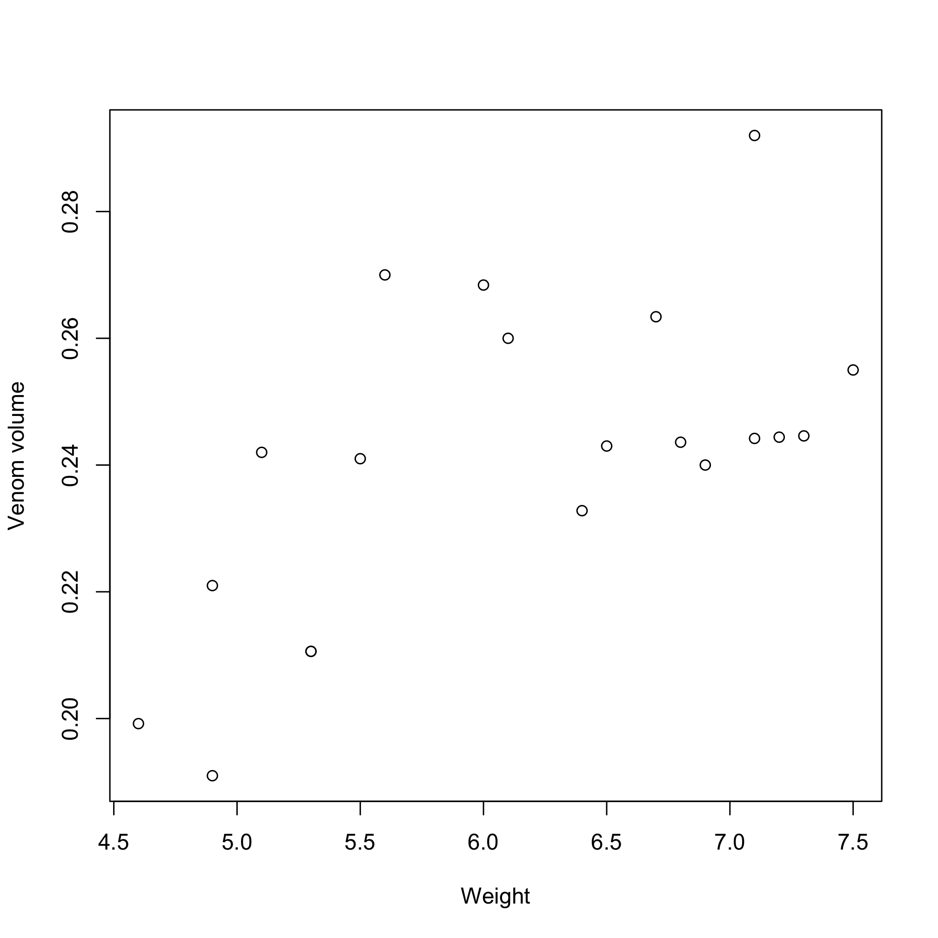

By convention, the descriptive variable is always on the x-axis, and the response variable is always on the y.

We will now produce a linear model to describe the relationship between weight and venom, to do this we use the “lm” command in R.

model.1<-lm(venom.vol~weight,data=weight.venom)

summary(model.1) ### Getting the results

lm(formula = venom.vol ~ weight, data = data)

Residuals:
Min 1Q Median 3Q Max
-0.029231 -0.014436 -0.008339 0.014551 0.038145

Coefficients:
Estimate Std. Error t value Pr(>|t|)
(Intercept) 0.138703 0.030997 4.475 0.000293 ***
weight 0.016634 0.004995 3.330 0.003722 **
---
Signif. codes: 0 ‘***’ 0.001 ‘**’ 0.01 ‘*’ 0.05 ‘.’ 0.1 ‘ ’ 1

Residual standard error: 0.02019 on 18 degrees of freedom
Multiple R-squared: 0.3813, Adjusted R-squared: 0.3469
F-statistic: 11.09 on 1 and 18 DF, p-value: 0.003722

You’ll notice that the output from R looks similar to the ANOVA outputs we’ve had before, but it’s not exactly the same. Instead of f-values, it’s given us t-values as well as “estimates” and “Std. Errors”. What do these mean?

What R has actually done with the “lm” command is to fit a line to our data, using the normal equation for a straight line..
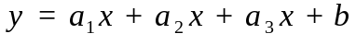
In our case, the estimate of the “(intercept)” from the output is above is b, and the estimate of “weight” is a. So R has built is a model describing the relationship between scorpion weight and the volume of venom it contains.

Other information from the “lm” output, and checking assumptions

At the bottom of the “lm” output are several other useful pieces of information. The “F-statistic” gives us an f-value and a p-value for weight that we report in the same way as we would from an ANOVA. In addition, the “R-squared” tells us what proportion of the total variation in the data our model has covered, in other words how good our model is. The R² is calculated by dividing the amount of variation the model explains by the total variation in the data. A higher value is clearly better, but unlike a p-value where we say that a value less than 0.05 is “significant”, there is no hard-and-fast rule of what constitutes a “good” R² value. In our above example, the adjusted R² is 0.3467, meaning our model explains about 35% of the data, which I suppose isn’t too bad.

An important aspect of linear modelling is making sure your model doesn’t violate any of the assumptions. The most important of these are..

- The relationship between your x and y variables is actually linear, this can be checked by looking for a pattern in the residuals
- The residuals are normally distributed, and their variance doesn’t increase with the value of the x-variable.

So that’s twice I mentioned “residuals”, so what are they?

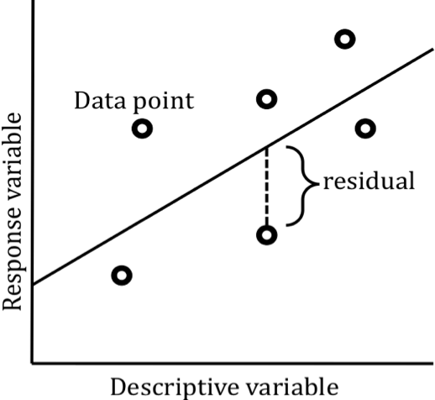
Every data point has a residual, that residual is the difference between the actual value of the data point, compared to its estimate from the model (the line in the above cartoon is the model). There should be no relationship between the value of the residuals, and the value of the x-axis, if there is, something maybe wrong with the model. To check if there’s a pattern, you simply use the “plot” command on your model…

plot(model.1)

In ours it looks like there may be a pattern in the residuals, at very low and very high weights the model seems to under predict the true values, and at intermediate values it tends to over predict. Doesn’t look too serious though. When it comes to checking these plots, again there don’t seem to be any hard rules, eyeballing and squinting tends to do the trick.

Visually presenting the model

There are multiple ways of achieving the same goal of representing your model on the plot of your data. The easiest way is to use the function “abline”. This is a very versatile function that can be used in multiple ways. To put our line on the graph, first we have to re-make the plot itself, do this using the same “plot” command line you used before. We can then either manually input the values of our line from the output of our model, putting the intercept as the first term and the estimate given for weight (the slope of the line) as the second, e.g.

abline(0.138703,0.016634)

Alternatively, we could just tell abline to take these values directly out of the model output..

abline(model.1)
You should now have something that looks like this..

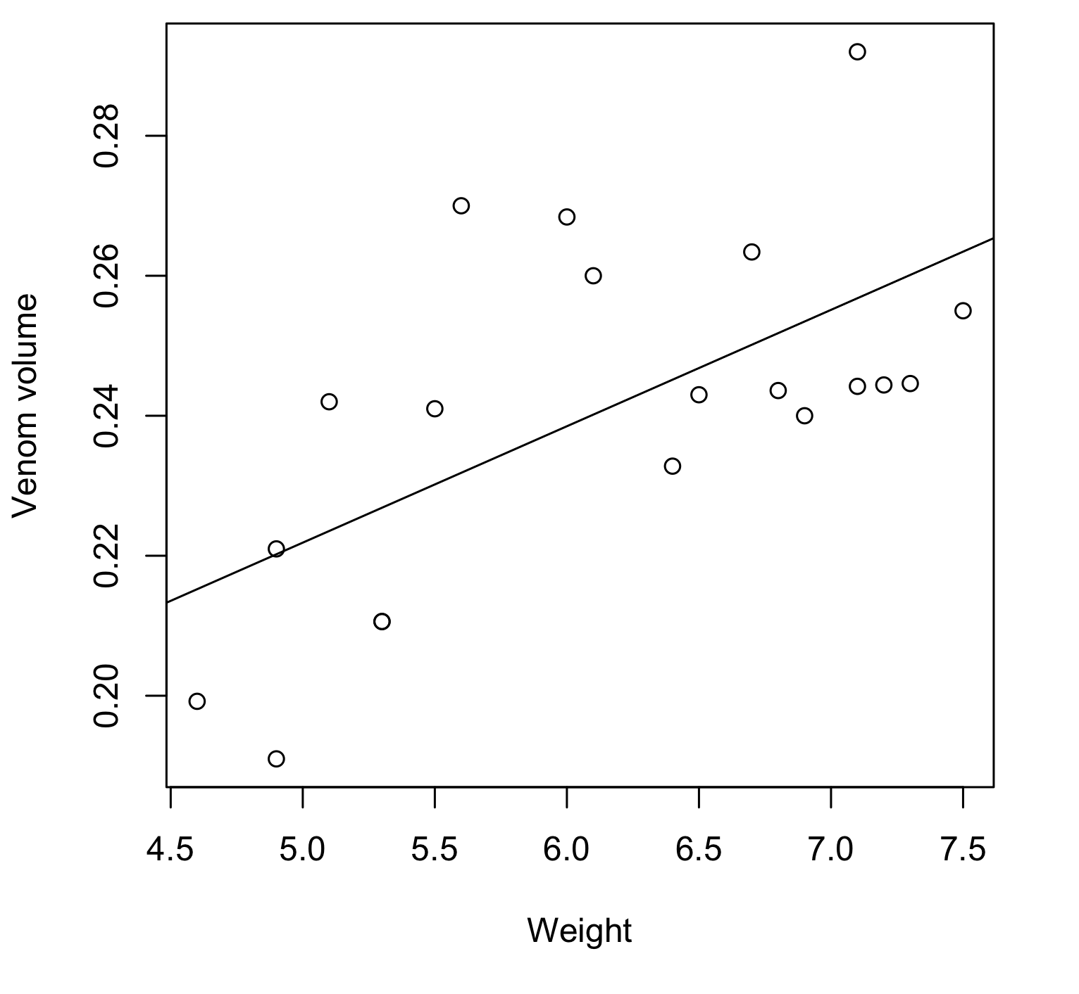
The look of the line can be adjusted using the normal “plot” argument. For instance, using the following command should produce a dashed line (make sure you make a new plot first, or abline will just draw the new line on the old one and you won’t see the difference!)

abline(model.1,lty=2)

Taking it a step further, building a function to draw the model, and the standard error of the model at the same time..

Although the abline function is useful to draw the model, if we could add standard errors around it, we would have some information about how precise it is. However, plotting standard errors along a gradient is difficult as we have the most amount of information at the middle of the range of our data, hence, we’ll be more confident in our estimate at the centre, and least confident at the extremes. We therefore need a way of reflecting this and can’t just put 2 straight lines either side of the original estimate.

To achieve this, we can use the “predict” function, this generates predicted, modelled data over a range of x-values. A key point of regression is that we shouldn’t really extrapolate off the end of the range of values we’ve used to generate the model. Therefore, we need to know what the range of our x-values were, we do this using the “range” function on our x-variable.

range(weight.venom$weight)
[1] 4.6 7.5

So the range of our x-variable is 4.6-7.5. Lets make a sequence of x-values over this range, 0.01 grams apart

x.values<-seq(4.6,7.5,0.01)

We can now use the “predict” function to produce predicting y-values by applying our original “model.1” to this sequence of y-values. Because we also want to add standard errors, within the “predict” command we shall specify that the “se.fit” argument is TRUE.

y.values<-predict(model.1,list(weight=x.values),se.fit=TRUE)
Within the “y.values”, we now have a vector of predicted (or “fitted”) data (y.values$fit), and a vector of predicted (or “fitted”) standard errors (y.values$se.fit). Using the “lines” command, we can then add these to the plot using the following commands. Redo the plot of the original data before trying to add the lines. I’m making the model predictions a solid line, and the standard errors dashed lines…

lines(x.values,y.values$fit) ## adding the actual model

## Adding the upper standard error (modelled data + s.e.)
lines(x.values,y.values$fit+y.values$se.fit,lty=2)

## Adding the lower standard error (modelled data - s.e.)
lines(x.values,y.values$fit-y.values$se.fit,lty=2)

This should produce the following plot…

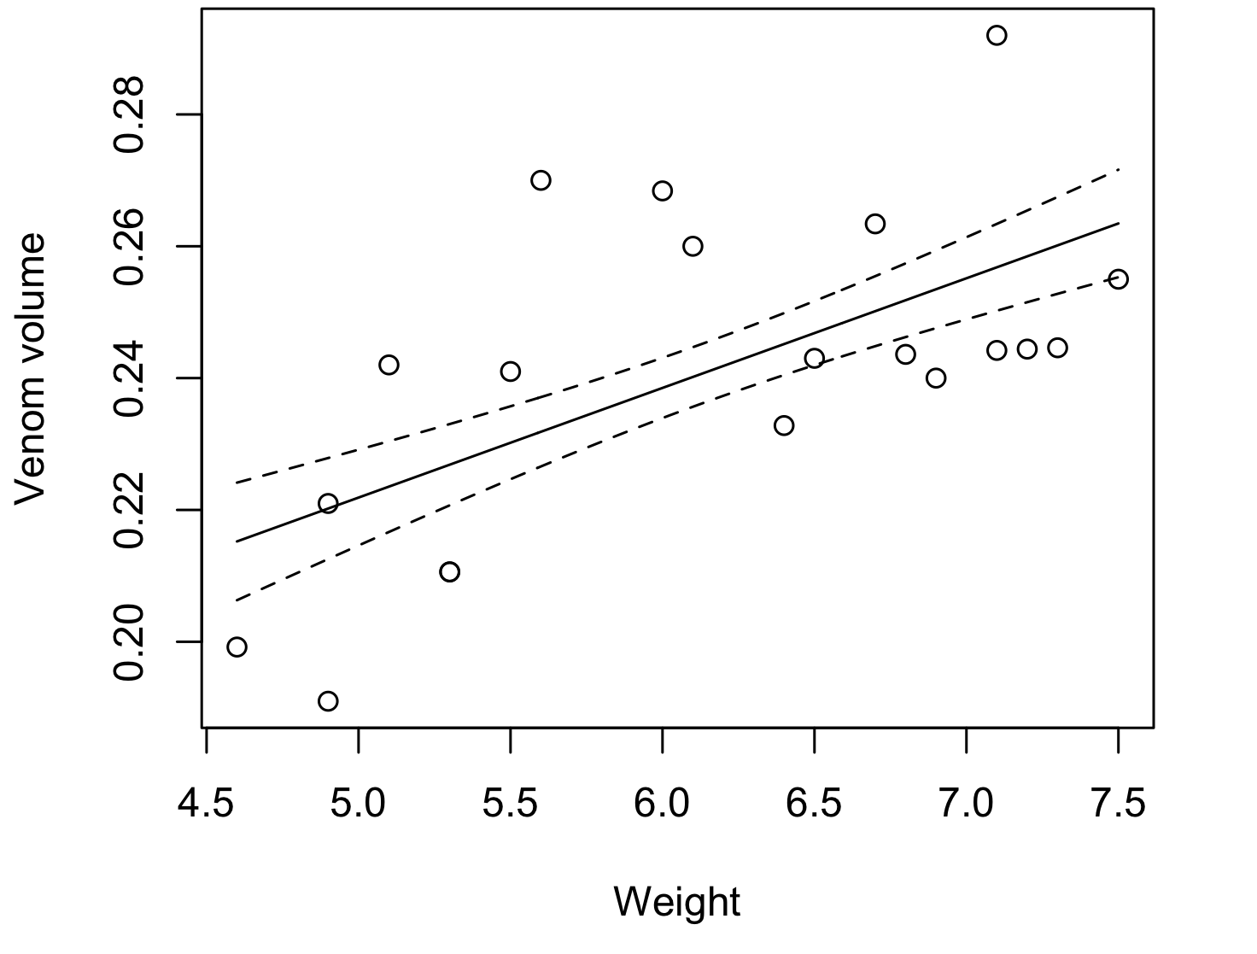
Beautiful.

TASK!
The data set “garter lengths.csv” has data on the lengths and speeds of 15 garter snakes. Use a regression test to see if the speed of a snake is affected by its length, plot the data, then add the modelled data and standard errors.

ANCOVA, a combination of regression and ANOVA
With many questions we have a combination of categorical and linear descriptive variables. For example, we may want to know how length and weight are related in 2 different salmon species, or whether the density of invertebrates changes as we move upstream or downstream of a source of pollution. We therefore need a statistical test that incorporates aspects of regression and ANOVA. This test is an ANCOVA, and analysis of covariance. Our covariates are our linear variables, in the above examples length and distance respectively. When we’re using ANCOVAs, we can also test for an interaction between our variables, asking the question “Does the relationship between linear variable A and linear variable B depend on the value of category C”. For instance, in the salmon example, we may notice that male salmon have humped backs, and we can use an ANCOVA to ask “Is the relationship between length and weight different for male and female salmon?”

Open the data set entitled salmon lengths, name the data set “salmon”.

To run the ANCOVA, we run a linear model as we did before, however we include “sex” as a categorical variable, along with the interaction. We can do this in a similar way to the multi-way ANOVA.

## This runs the initial model
salmon.mod<-lm(weight~length*sex,data=salmon)

This model is essentially fitting the following model..

## getting the parameter estimates for the model
summary(salmon.mod)

Coefficients:
Estimate Std. Error t value Pr(>|t|)
(Intercept) 289.876 216.812 1.337 0.1999
length 117.364 7.081 16.575 1.69e-11 ***
sexmale 236.668 299.941 0.789 0.4416
length:sexmale -18.568 8.507 -2.183 0.0443 *
---
Signif. codes: 0 ‘***’ 0.001 ‘**’ 0.01 ‘*’ 0.05 ‘.’ 0.1 ‘ ’ 1

Residual standard error: 287.4 on 16 degrees of freedom
Multiple R-squared: 0.9794, Adjusted R-squared: 0.9755
F-statistic: 253.4 on 3 and 16 DF, p-value: 1.079e-13

The numbers in the first column of the above table are the estimates of values a₁ – a₃. To get an ANOVA table for the above test, just use the “anova” command.

anova(salmon.mod)

Analysis of Variance Table
Response: weight
Df Sum Sq Mean Sq F value Pr(>F)
length 1 61866037 61866037 748.9507 7.262e-15 ***
sex 1 531649 531649 6.4361 0.02197 *
length:sex 1 393495 393495 4.7637 0.04432 *
Residuals 16 1321658 82604

As we have a significant interaction term, it means the relationship between length and weight is different between the sexes. Remember, if you have a significant interaction you must focus discussion on the interaction rather than the main effects.

This best demonstrated with a figure…

Firstly, plot the actual data, although use the “ifelse” function within the “pch” function to label the points with different characters. If you are unsure of these functions, look them up using “help()”

plot(salmon$length,salmon$weight,pch=ifelse(salmon$sex=="male",1,19))

We can then use the abline function, with versions of our model inside it to put on the lines from the model.

## This line adds the predictions for male fish
abline(lm(weight[sex=="male"]~length[sex=="male"],data=salmon),
lty=3,lwd=2)

## This line adds the predictions for female fish
abline(lm(weight[sex=="female"]~length[sex=="female"],data=salmon),lty=1,lwd=2)
## we can also add a legend to the plot, using the “legend()” command
## The first 2 numbers are the x and y coordinates, then we have the ## labels, “lty” and “pch” dictate the line/point types as before.
legend(50,4000,c("Male","Female"),bty="n",lty=c(3,1),pch=c(1,19),lwd=2,cex=1.2)

The eventual figure should look like this…

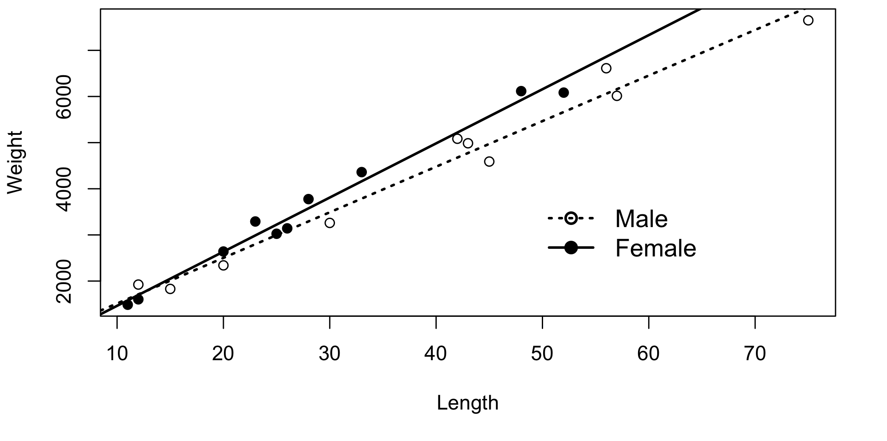
Remember, because the lines are not parallel, this means the relationship between length and weight is different for the different sexes. As a result, we can’t make statements about how increased length affects salmon weight without knowing which sex we’re talking about. If the lines are parallel, this means the slope of the relationship between length and weight is the same for the 2 sexes, but one sex is always heavier.

If we have no significant interaction, we remove the interaction term by changing the “*” to a “+” just as we did for the multi-way ANOVA, and re-run the model. The model MUST be re-ran without the interaction term to obtain the correct results, numbers of degrees of freedom etc.

TASK!

The data set “mosquitoes.csv” contains lengths and plasmodium loads of 2 different Anopheles mosquito species. Firstly bring the data set into R.

Is do larger mosquitoes have a higher plasmodium load than smaller mosquitoes? Do A. gambiae contain a higher number of plasmodium than A. funestus? Run and ANCOVA on the data, interpret the results, and produce a graph as before.
MULTIPLE REGRESSION

We have now covered situations where we have a single, categorical descriptive variable, multiple categorical descriptive variables, a single continuous descriptive variable, and a combination of descriptive and continuous variables. All in all we’ve covered a lot, and now have a reasonably versatile range of tools available to analyse different sorts of data. The last step before we jump up a level of complexity is to look at situations when we have multiple linear variables.

Open the dataset “frogs.csv”, this data frame contains details of the mean length, weight, and jump height of 25 frog species.

We would assume that larger frogs could jump higher, but we have 2 measures of size. If we do regressions of the two size metrics (length and weight) separately, we get the following results….

## Length….

length.mod<-lm(height~length,data=frogs)
summary(l.1)

Coefficients:
Estimate Std. Error t value Pr(>|t|)
(Intercept) 3.69436 0.88168 4.190 0.000351 ***
length 0.45301 0.08624 5.253 2.5e-05 ***

### So jump height is positively correlated with length, with ### a formula “jump heigh = length*0.45+3.69”

### WEIGHT

weight.mod<-lm(height~weight,data=frogs)
summary(w.1)

Estimate Std. Error t value Pr(>|t|)
(Intercept) 5.98300 1.14692 5.217 2.73e-05 ***
weight 0.05983 0.03155 1.897 0.0705 .

### Jump height appears very slightlys positively correlated ### with weight, but the relationship is not quite significant
### formula “jump height = weight*0.07+1.922

We can plot the results below, the “par” command is useful for putting multiple plots on one page. The numbers in the brackets denote the number of rows and columns of graphs you’re intending to plot

par(mfrow=c(1,2))
plot(height~length,lwd=2,data=frogs,xlab="length",ylab="Jump height")
abline=(length.mod)

plot(height~weight,lwd=2,data=frogs,xlab="weight",ylab="Jump height")
abline=(weight.mod)

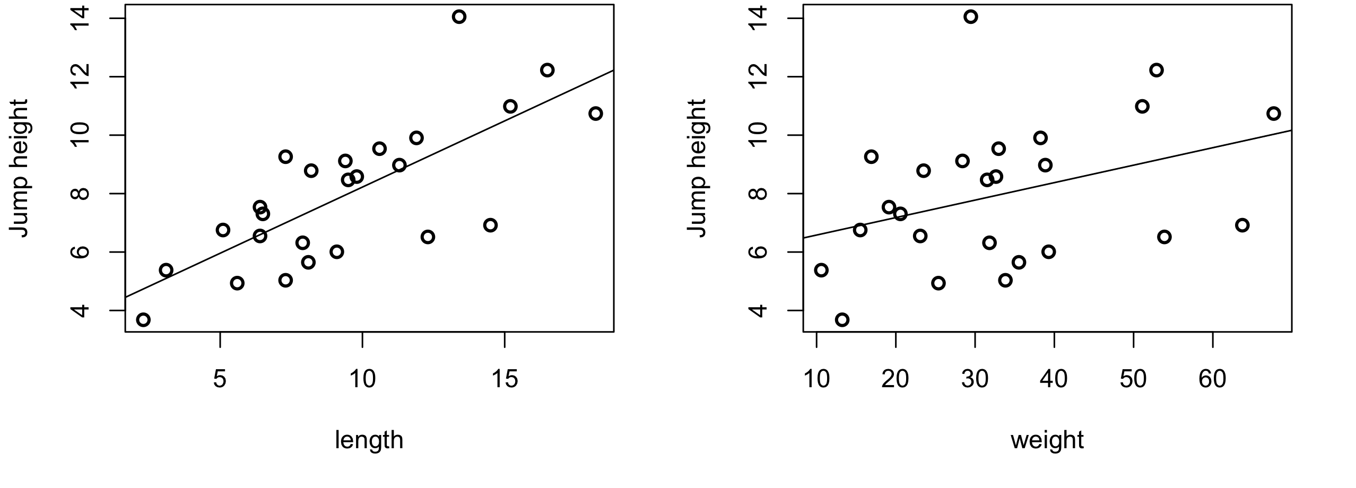

So what is going on? Well, we may have an issue that length and weight should also be correlated with each other, as longer frogs are likely to be heavier. Lets look at the relationship between length and weight…

length.weight<-lm(weight~length,data=frogs)
summary(length.weight)

Coefficients:
Estimate Std. Error t value Pr(>|t|)
(Intercept) 1.223 3.527 0.347 0.732
length 3.388 0.345 9.821 1.07e-09 ***

So length and weight are positively correlated, with the relationship..

Weight = length*3.39 + 1.22

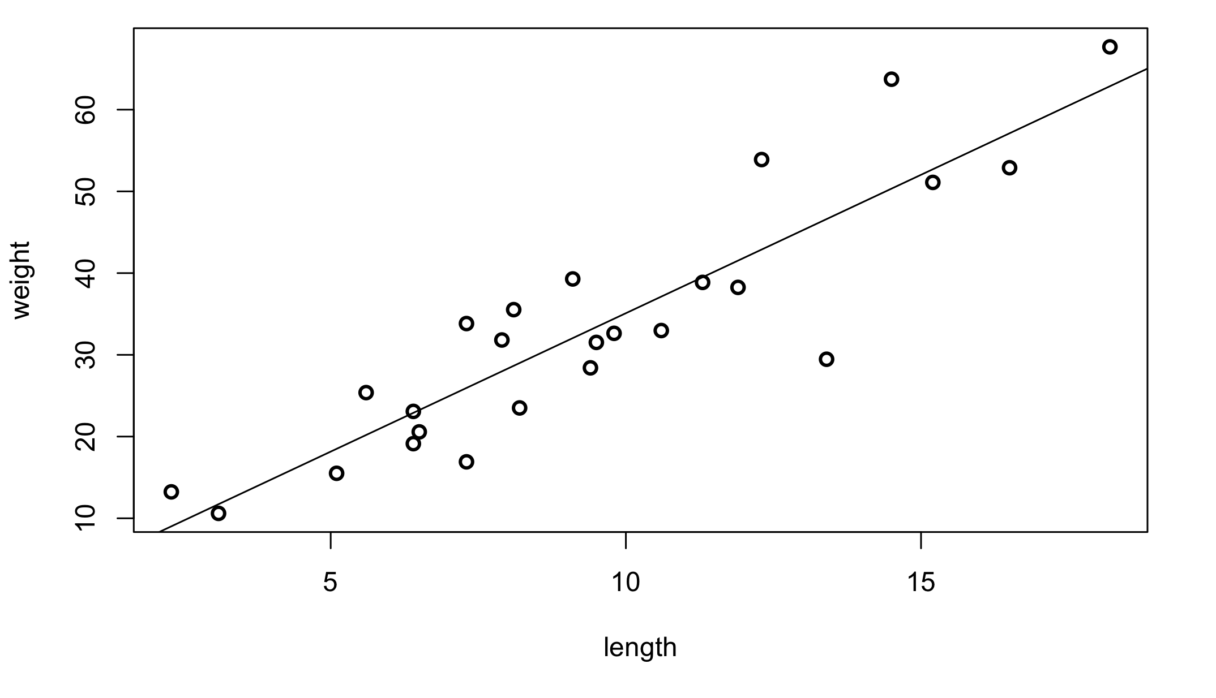
In the above plot, the frogs above the line are relatively heavy for their length, and the frogs below the line are relatively light for their length. Lets look again at the relationship between length and jump height, but this time label the points as to whether they’re relatively heavy or light, using the formula for weight we got from the last regression, and add the line for the regression of jump height by length to the plot

par(mfrow=c(1,1))
plot(height~length,pch=ifelse(weight<length*3.39+1.22,19,1),lwd=2,data=frogs,xlab="length",ylab="Jump height")
abline(length.mod)

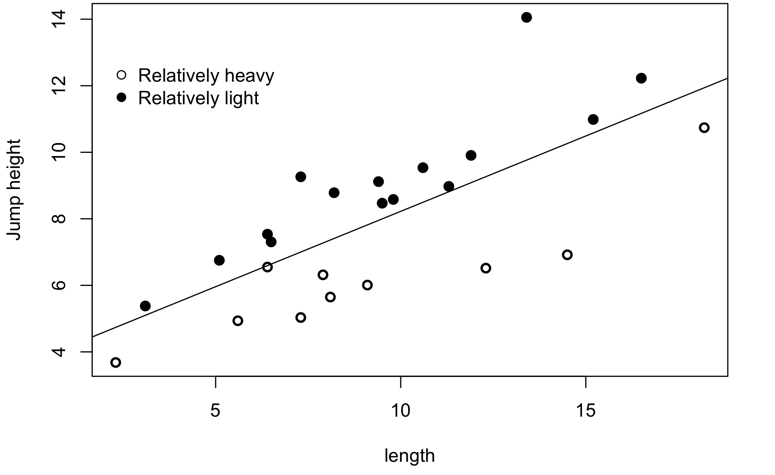
We can see here that the relatively light frogs can all jump higher than would be predicted from their length (they’re all above the line), and the relatively heavy frogs cannot jump as high as we’d predict (they’re all below the line). If we now produce a model that incorporates both height and weight, we can formalise the relationship…

Full.mod<-lm(height~length+weight,data=frogs)
summary(full.mod)

Residuals:
Min 1Q Median 3Q Max
-2.998e-15 -1.495e-15 -7.479e-16 -1.870e-16 1.185e-14

Coefficients:
Estimate Std. Error t value Pr(>|t|)
(Intercept) 4.000e+00 1.659e-15 2.411e+15 <2e-16 ***
length 1.300e+00 3.688e-16 3.525e+15 <2e-16 ***
weight -2.500e-01 9.783e-17 -2.556e+15 <2e-16 ***

We can see from this that indeed weight has a negative effect on jump height, the only reason we saw a positive relationship in the model of jump height by weight is because length and weight are correlated. The true model for the relationship between length, weight and jump height is…

Jump height = length*1.30-weight*2.5+4.00

So fat frogs can’t jump as high.

Whenever we’re doing these multiple regressions, we always, as usual test for interactions first.

Graphing the actual relationships in multiple regressions can also be very difficult, you may opt for 3D plots, but generally they’re to be avoided.

LAST NOTE ON ANOVAs to multiple regressions

As it’s actually possible to include any number of different linear and categorical descriptive, we can now analyse some very complex data. Always remember the general rules…

- Test interactions first
- If using stepwise removal, remove non-significant terms one at a time.

Including lots of descriptive variables is often very appealing, but remember that the more variables you include, the harder it’s going to be to explain and graphically represent the results. 4-way interactions for example are as good as impossible.

NON-LINEAR DATA:- GENERALISED LINEAR MODELS AND LOGISTIC REGRESSION
There are many situations where obtaining nice, normally distributed data, with a clear linear relationship between the descriptive and response variable just isn’t possible. Fear not, there is a large field dedicated to dealing with these sorts of issues. Non-linear data can be dealt with using “generalised linear models”, these are models were a “link function” is used so that a “linear predictor” (basically the y=ax+b that we used in our linear model) can be made to produce non-linear shapes.

The field of generalised linear modelling is vast, and the types of data that can be analysed and range of shapes is enormous. We are going to focus here on one particular common problem, dealing with proportional data.

The main issue with proportional data is that it is bounded by 0 and 1, hence it can never be normal (once of the assumptions of normality is that the data can go from negative infinity to positive infinity). Also, the relationship between our descriptive and response variables is unlikely to be linear (in fact, it’s physically impossible).

Here’s an example, we are looking at a new brand of pesticide, and looking at how lethal it is.

We collect the following data..

dose | alive | dead
1 | 78 | 2
2 | 74 | 3
3 | 65 | 6
4 | 55 | 34
5 | 45 | 45
6 | 25 | 67
7 | 5 | 78
8 | 1 | 82
9 | 0 | 102
10 | 0 | 85

This data set is called “insect dosage”, bring it into R and call it “dosage”

In this case, our response variable is actually made up of 2 different columns, the number alive, and the number dead. We can also express this as a single column, which we’ll call “prop.dead”

dosage$prop.dead<-dosage$dead/(dosage$alive+dosage$dead)

If we plot the proportion dead against the dosage we get the following graph..

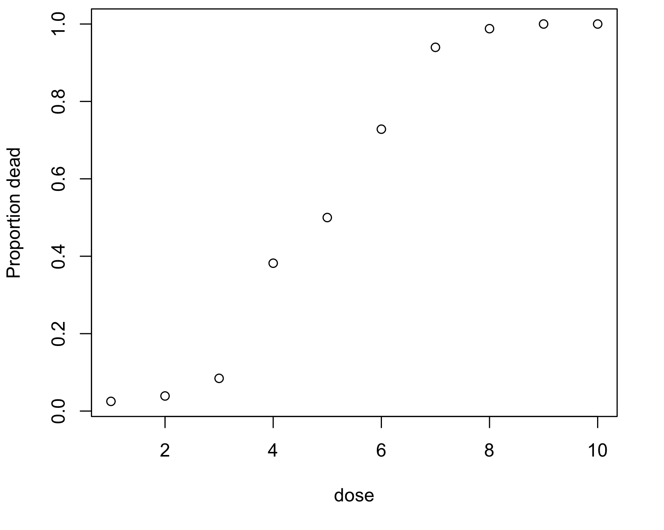
We could try fitting a regular linear model to our data…

mod1<-lm(prop.dead~dose, data=dosage)
summary(mod1)
Estimate Std. Error t value Pr(>|t|)
(Intercept) -0.16205 0.07828 -2.07 0.0722 .
dose 0.13285 0.01262 10.53 5.76e-06 ***

Now this has given us a significant result, so all initially looks good, but lets plot the model against the data..
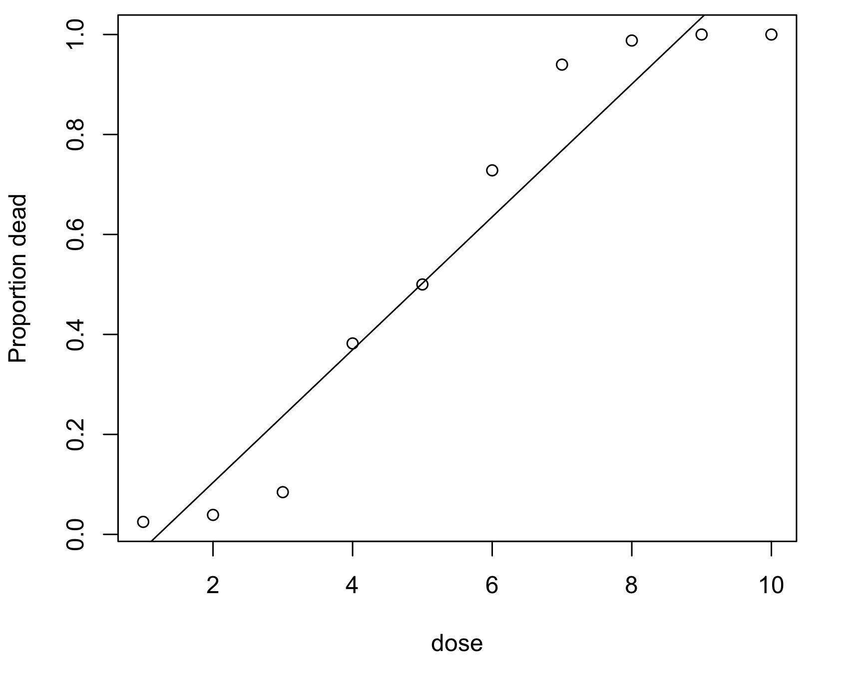
Now we start seeing some issues, for a start the model predicts that above a dosage of about 9, we get a death rate of over 100% (impossible) and below about 0.5 we get a death rate lower than 0% (also impossible). The fit is also pretty horrid. We need a model that doesn’t assume a linear relationship, and our data is not normally distributed.

We therefore use a binomial distribution, which assumes a Logistic Link function. Remember our response variable is made up of 2 components, dead and alive. We can think of these as the two possible outcomes that make up our binomial distribution, and each animal is a “trial”. We therefore need to combine them together to do our model, and we do this with “cbind”. As we’re running a generalised linear model, we use “glm” rather than “lm”. Our model is therefore..

mod2<-glm(cbind(dead,alive)~dose,data=dosage,family=binomial)
summary(mod2)

Estimate Std. Error z value Pr(>|z|)
(Intercept) -5.36083 0.38903 -13.78 <2e-16 ***
dose 1.11546 0.07591 14.70 <2e-16 ***

Everything is still significant as before, but the difference in the models is apparent when we plot the fitted values (prediction of the model)

plot(dose,prop.dead,ylab="Proportion dead",xlab="dose",data=dosage)
lines(dosage$dose,mod2$fitted.values,type="l",lwd=2)

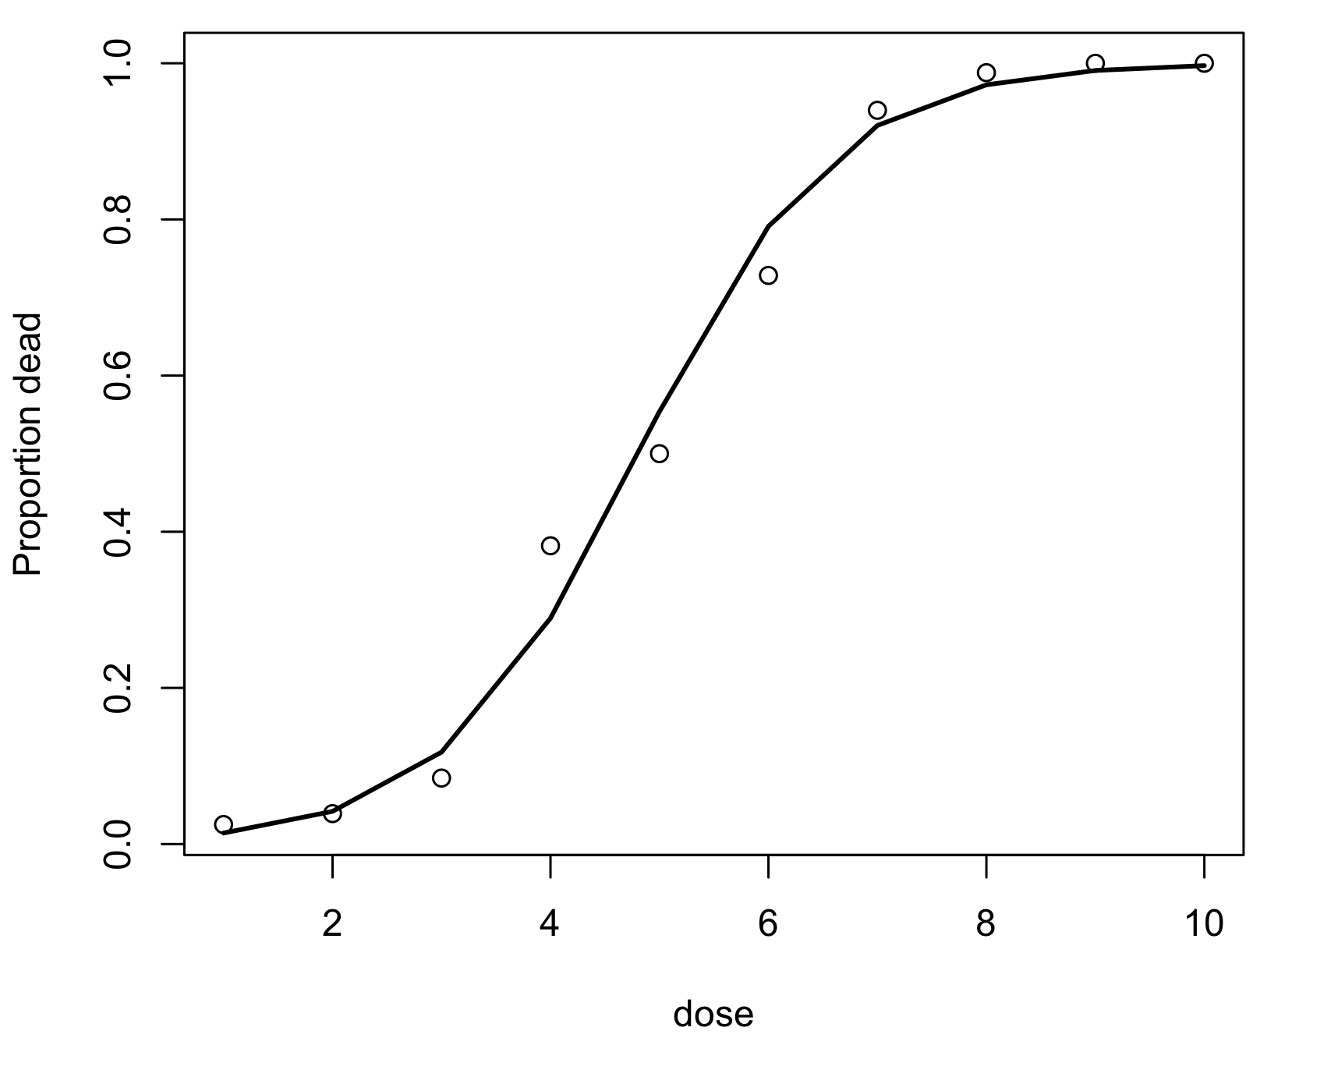
That model is clearly a better fit to the data, and it is no longer predicting impossible values.

BINARY RESPONSE VARIABLES
We regularly obtain data with binary response variables, where for each trial or replicate 2 possible outcomes cover the whole range of possibilities. Eg, alive or dead, male or female, won or lost. These can be analysed using logistic regression as described above.

We know that in many reptiles, sex is determined by egg temperature. The data set “crocs” contains details of egg temperature, and whether or not the juvenile turned out as male (male = 1) or female (male = 0). We can make a plot, and fit a model..

mod3<-glm(male~temp,data=data,family=binomial)
plot(temp,male,data=data,ylab=”sex”,xlab=”temperature”)
lines(data$temp,mod3$fitted.values,lty=1,lwd=2)
abline(h=0.5,lty=2) ### This draws the horizontal line
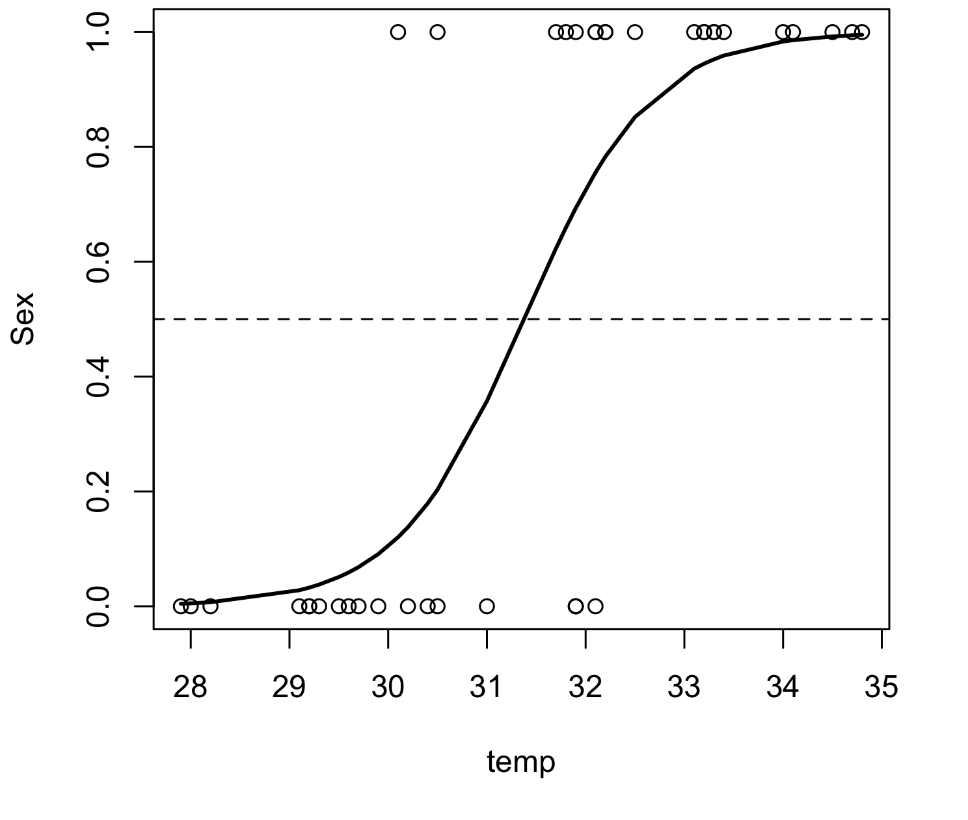
From the above figure it’s easy to see that sex in crocodiles is determined by temperature, and that if the temperature is above around 31.2 degrees the crocodile will be male.

These examples of logistic regression are only one possible application of generalised linear models, the boundaries are only formed by your imagination. However, non-linear models can get very complex very quickly, and shouldn’t be used just because you’ve collected slightly ropey data. Their potential uses and forms extend well beyond the scope of this course, however there is a great deal of literature available on them both online and in print should you decide to explore further.

MIXED EFFECTS ANOVA, INTRODUCING RANDOM EFFECTS
In all the tests we have done so far we have only dealt with “fixed” effects, descriptive variables where we care exactly about the magnitude of differences, and whether or not particular treatments are different from each other. However, sometimes, we have situations where we don’t care about the absolute magnitude of differences, we just want account for differences. In other words, we only really care about the variance, the variation in the data that’s accounted for by a particular variable. These are known as “random variables”.

This concept can be difficult to understand, so don’t get disheartened if it doesn’t seem clear right away. It might be best done using an example.

Due to climate change, the ranges and abundances of butterfly species in the United Kingdom are changing, and are the subject of a great deal of public research. As butterflies are very charismatic, there are lots of volunteers collecting data on them continuously, and using these data rather than organising our own research can save time, money, and mean we have more available. The downside is, each collector will most likely collect the data in their own unique way. Some will simply walk around counting butterflies, some will catch them in nets, some will use traps. Because of these differences in collection method, we will expect differences due in the number recorded in each survey, but we have no real idea of why (we’re unaware of the methods they used). The differences due to collector are therefore random. Also, we’re not really that interested in who collected the most or least butterflies. What we’re interested in is differences in butterfly abundances between agricultural fields and forests at different times of the year. We receive data collected by 3 different volunteers, each of whom collected data on butterfly abundances…

butterflies | location | season | collector
15 | field | fall | Brian
14 | field | fall | Brian
14 | field | fall | Brian
13 | field | fall | Brian
18 | field | summer | Brian
19 | field | summer | Brian
18 | forest | fall | Brian
17 | forest | fall | Brian
19 | forest | fall | Brian
18 | forest | fall | Brian
19 | forest | fall | Brian
30 | forest | summer | Brian
32 | forest | summer | Brian
31 | forest | summer | Brian
31 | forest | summer | Brian
14 | field | fall | Ken
15 | field | fall | Ken
11 | field | fall | Ken
15 | field | summer | Ken
16 | field | summer | Ken
15 | forest | fall | Ken
18 | forest | fall | Ken
15 | forest | fall | Ken
17 | forest | summer | Ken
26 | forest | summer | Ken
16 | field | fall | Sally
19 | field | summer | Sally
21 | field | summer | Sally
21 | field | summer | Sally
30 | forest | summer | Sally

Remember, the main question we’re interested in is how do abundances differ by location and during the seasons. There will be some variation in abundances due to this different collectors, and we have to account for this, but we’re not necessarily interested in the magnitude of the differences between collectors.

We therefore analyse the data with mixed effects ANOVA. The fixed effects we’re interested in are “location” and “season” (and the interaction), and the random effect is “collector”.

There isn’t a function to do mixed effects modelling in the base R package, so we have to install a new package. To do this, click the “packages & data” menu, then click “package installer”. It will ask you to “choose a local mirror”, choose one nearby (most likely SFU, British Columbia). Then search for the package entitled “nlme”, and install, making sure to click “install dependencies”. Then open the package in R using the following command line…

library(nlme)

The package, and all it’s functions are now installed. This package contains a function called “lme” that is an extension of the “lm” linear modelling command, and allows mixed effects modelling.

Bring in the butterflies data set, call it “butter”

You can then build the ANOVA model, we include the fixed effects as we always have, but specify the random effects using “random=~1|collector”.

The full coding is therefore.

mix.mod<-lme(butterflies~location*season,random=~1|collector,data=butter)

We can then look at the results as before.

summary(mix.mod)

Linear mixed-effects model fit by REML
Data: butter
AIC BIC logLik
140.0766 147.6251 -64.03828

Random effects:
Formula: ~1 | collector
(Intercept) Residual
StdDev: 2.565986 2.207966

Fixed effects: butterflies ~ location * season
Value Std.Error DF t-value p-value
(Intercept) 14.533440 1.688544 24 8.607085 0.0000
locationforest 3.622379 1.112514 24 3.256031 0.0034
seasonsummer 3.568205 1.184183 24 3.013221 0.0060
locationforest:seasonsummer 6.091906 1.621905 24 3.756019 0.0010
Correlation:
(Intr) lctnfr ssnsmm
locationforest -0.309
seasonsummer -0.338 0.431
locationforest:seasonsummer 0.212 -0.686 -0.658

Standardized Within-Group Residuals:
Min Q1 Med Q3 Max
-3.72197462 -0.34235798 0.01193229 0.33468464 1.38792773

Number of Observations: 30
Number of Groups: 3

This may look confusing, but we just need to know where to look. At the top we have the random effects, R doesn’t give us a p-value as recall we’re not necessarily interested in the how random effects relate to abundance, we just want the model to account for the fact they do. The fixed effects (what we’re interested in) are presented in an ANOVA table that we can read as before. If we want to get F-values for each of the fixed effects as before, we just do “anova(mix.mod)

As an indication of the importance of random effects, lets try running a model with only the fixed effects, ignoring the differences due to collector..

fix.mod<-lm(butterflies~location*season, data=butter)

summary(fix.mod)

Call:
lm(formula = butterflies ~ location * season, data = butt)

Residuals:
Min 1Q Median 3Q Max
-11.1429 -0.8571 0.5982 1.7991 3.8571

Coefficients:
Estimate Std. Error t value Pr(>|t|)
(Intercept) 14.000 1.057 13.243 4.57e-13 ***
locationforest 3.375 1.495 2.258 0.03260 *
seasonsummer 4.429 1.547 2.862 0.00821 **
locationforest:seasonsummer 6.339 2.188 2.897 0.00755 **
---
Signif. codes: 0 ‘***’ 0.001 ‘**’ 0.01 ‘*’ 0.05 ‘.’ 0.1 ‘ ’ 1

Residual standard error: 2.99 on 26 degrees of freedom
Multiple R-squared: 0.7764, Adjusted R-squared: 0.7506
F-statistic: 30.09 on 3 and 26 DF, p-value: 1.304e-08

Although we get the same essential result, look at the t and p-values. In the mixed model the t’s are much higher, and the p’s are much lower. This means that adding in the fixed effects means we have much more statistical power, and more confidence in our results.

There are many situations in which we would make particular variables random. For example, in any experimental design where the treatments are assigned to different blocks, the “block” variable will be random.

TASK!
Upload the data set “trout.csv”. The data set contains lengths of 2 different salmonid species of different sexes caught from different locations. We are interested in whether males are bigger than females, and if different species are of different sizes.

Which variables are random, and which are fixed?

Analyse the dataset and explain the results.

REPEATED MEASURES AND MIXED EFFECTS

One very useful feature of mixed effect modelling is that it allows us to deal with data when we have repeated measures, for example, if we’re measuring the same plant at different times to see how fertiliser additions affect plant size, or multiple measurements on a plot for example. In these situations, the multiple measurements on the same subject are known as “temporal pseudoreplicates”. Because 2 measurements on the same subject are likely to be more similar than 2 measurements on different subjects, we have to account for that. Again, this is probably best demonstrated with an example.

Say we wanted to see whether or not lions hunt more successfully on open savannah or in tall grass. Lion prides have large territories, meaning we’re not going to be able to follow many of them, in our case three prides, and each pride is going to be catching multiple prey. Hence, over the course of a season we’re going to get multiple records from each pride. These records per pride are therefore technically pseudoreplicates, taken through time. If we were to treat each pride as an independent data point, then our total n would only be three, which is rubbish frankly. Hence, we’ll use mixed effects. The prides will differ in multiple ways (number of members, hunting technique, quality of territory etc), and hunting ought to be better later in the season when the number of migratory ruminants has increased. In our total data set we have the number of prey killed per pride, per fortnight (2 weeks), for 14 weeks, in savannah or long grass. So, if we take “pride” as a random variable, and it’s pseudoreplicated through time, we now have a linear component to the “random” part of the model. To do this, we modify the “random=~1|……” part of our command to include the linear variable of time.

Import the data set “lions.csv” into R.

Run the mixed effects model using the following command, you can see we’ve changed the “1|” from before to “fortnight|pride”, this is saying that “pride” is our random variable, pseudo-replicated by time (fortnight)

mix.2<-lme(killed~location,random=~fortnight|pride,data=lions)
summary(mix.2)

Linear mixed-effects model fit by REML
Data: lions
AIC BIC logLik
152.8166 162.9499 -70.40832

Random effects:
Formula: ~fortnight | pride
Structure: General positive-definite, Log-Cholesky parametrization
StdDev Corr
(Intercept) 1.2170657 (Intr)
fortnight 0.3282798 -0.766
Residual 1.1627001

Fixed effects: killed ~ location
Value Std.Error DF t-value p-value
(Intercept) 5.533303 0.5263599 38 10.51240 0
locationsavannah -1.952381 0.3588170 38 -5.44116 0
Correlation:
(Intr)
locationsavannah -0.341

Standardized Within-Group Residuals:
Min Q1 Med Q3 Max
-1.5838254 -0.7031535 0.1143584 0.6377797 1.8893674

Number of Observations: 42
Number of Groups: 3

We interpret and report the value of the fixed effect (location, remember our main question) from before. To get the actual f and p values, once again we use the “anova()” command

anova(mix.2)
numDF denDF F-value p-value
(Intercept) 1 38 84.81033 <.0001
location 1 38 29.60622 <.0001

We can therefore see that lions are significantly better at hunting in one location than the other.

IS MY VARIABLE RANDOM OR FIXED?
Good question. It will largely depend on the question you want your data to answer. In the case of the lions, our main question was “Do lions hunt better in savannah or long grass”, we didn’t really care which pride was better than others, we just knew there would be some variation due to pride. If we wanted to ask specifically if one pride was better than another, then we would have to put “pride” as a main effect, and our model becomes different.

Generally, random effects are things where you’re not concerned with what their effect actually is, just that you know it will account for some of the variation. Blocking terms are a good example of this. When we’re using a blocked design, we don’t really care about comparing the differences between blocks, we just want to account for the difference between blocks.

If we’re dealing with repeated measures, and our main question isn’t “do these particular subjects differ?” then we have to use random effects. An important point is that you must decide which variables will be random or fixed and the design phase of the experiment, these techniques shouldn’t be used to “fix” bad designs.

GETTING VERY COMPLICATED
It is possible to combine mixed effects into a non-linear model. This will get very complex very quickly however, and is outside the range of this course. The definitive guide to doing this is given in the book….

“Jose C. Pinheiro, Douglas M. Bates - Mixed Effects Models in S and S-Plus”

There’s also bits of this stuff in “The R Book” by Crawley.

MULTIVARIATE STATISTICS
So far we have only dealt with situations in which we only have a single response variable, and one or more descriptive variables. For example, when we were looking at the number of butterflies collected at different times of the year, “Number caught” was out single response variable, and our descriptive variables were “location”, “season” and “collector”. Using this system of “single-response, multiple descriptive” we can answer a lot of questions and test many hypotheses.
Sometimes however, we are dealing with data where we have multiple different response variables. For example, in the butterfly data we previously used, we may also want to ask if there are differences in butterfly community composition (relative abundances of different species), as well as differences in absolutle number. In this situation we will have multiple response variables (the abundance of each species will be a different response variable). Community composition questions are very common, and are very popular at present. Alternatively, we may take multiple measurements of each of our test subjects, and want to look at how they’re related. This is often used in genomics research where for each individual in our study we have expression data for thousands of genes. Each of these gene expressions then becomes a different response variable.

To deal with these complex data we use a range of “multivariate statistics”. We will go through the basics of three different types here, MANOVA (Multivariate Analysis of Variance), NMDS (Nonmetric Multidimensional Scaling) and PCA (Principal Components Analysis). Each of these analytical techniques different advantages and limitations, and which is most appropriate will depend on the situation.

MANOVA
MANOVA is the simplest multivariate statistics, and in many situations is perfectly adequate. A MANOVA is exactly what it sounds like, an ANOVA but with multiple different explanatory variables.

Trisha Atwood and I conducted a study looking at whether or not the presence of predators affected insect biomass, plant biomass, and CO₂ concentrations in natural ponds and artificial ecosystems (tanks). We therefore had a 2x2 factorial design (tank or pond vs. predator or control) but had 3 different response variables. We could simply do separate ANOVAs, but in the same was as conducting multiple t-tests instead of an ANOVA increases your chances of finding a significant difference when it isn’t there, conducting multiple ANOVAs on the same subjects but looking at different response variables is very naughty. It is naughty for 2 reasons, firstly you’re more likely to accidently find significant differences, because with any test at the 95% level there’s a 5% chance you’re wrong. So if you have three tests the chance of at least one being wrong is….
1-(95%*95%*95%) = 1-85.7% = 14.3%

Also, if the different response variables are measured on the same subject, they are likely to be correlated. Hence, if one is significantly different then it’s likely the others are as well.

The solution is to perform a MANOVA analysis to check for differences between the treatments BEFORE looking at the individual ANOVAs, and then using Bonferroni correction to your ANOVAs more conservative.

As usual it’s best explained with an example.
Bring the data set “manova data.csv” into R, call it ‘man.data’.

Use the command “head(man.data)” to have a look at the columns, this command will show you the top 5 rows.

type treatment co2 plant insects
1 Pond control 343.3781 35.97434 0.25573679
2 Pond control 496.0875 29.93452 0.21050801
3 Pond control 323.5566 33.34101 0.02829829
4 Pond control 362.4891 48.68437 0.28149888
5 Pond control 410.5976 55.26698 0.07760674
6 Pond predator 285.2831 72.83254 0.01227748

The first thing we need to do is combine the three response variables together, we can then run the test. We do this with the “cbind” command as we did with the logistic regression.

y<-cbind(man.data$co2,man.data$plant,man.data$insects)
y ### Having a look at “y” to check it’s right.

We can then produce the MANOVA model in a similar way to an ANOVA

man.1<-manova(y~man.data$treatment*man.data$type)

summary(man.1) ### Looking at the results…

Df Pillai approx F num Df den Df Pr(>F)
treatment 1 0.73665 22.378 3 24 3.900e-07 ***
type 1 0.89777 70.257 3 24 4.995e-12 ***
treatment: type 1 0.44388 6.385 3 24 0.002458 **
Residuals 26

From this we can see we have a significant treatment:type interaction. This means the combination of the three response variables is different between our ecosystems with and without predators. Although the effect of predators is different for the two ecosystems.

As we have a significant result for our MANOVA, we know our treatments are different, and we can be justified in looking at the individual ANOVAs. We can do this using the “summary.aov” command on our MANOVA model. Response 1 is co2, response 2 is plant, and response 3 is insects.

summary.aov(man.1)
Response 1 :
Df Sum Sq Mean Sq F value Pr(>F)
treatment 1 40142053 40142053 11.6330 0.002126 **
type 1 264324855 264324855 76.6005 3.15e-09 ***
treatment:type 1 18646473 18646473 5.4037 0.028171 *
Residuals 26 89717980 3450692
---
Signif. codes: 0 ‘***’ 0.001 ‘**’ 0.01 ‘*’ 0.05 ‘.’ 0.1 ‘ ’ 1

Response 2 :
Df Sum Sq Mean Sq F value Pr(>F)
treatment 1 2399.4 2399.4 54.2560 8.028e-08 ***
type 1 6343.0 6343.0 143.4316 4.379e-12 ***
treatment: type 1 111.6 111.6 2.5246 0.1242
Residuals 26 1149.8 44.2
---
Signif. codes: 0 ‘***’ 0.001 ‘**’ 0.01 ‘*’ 0.05 ‘.’ 0.1 ‘ ’ 1

Response 3 :
Df Sum Sq Mean Sq F value Pr(>F)
treatment 1 0.016323 0.016323 7.5355 0.0108245 *
type 1 0.068107 0.068107 31.4417 6.82e-06 ***
treatment: type 1 0.030707 0.030707 14.1759 0.0008601 ***
Residuals 26 0.056319 0.002166
---
Signif. codes: 0 ‘***’ 0.001 ‘**’ 0.01 ‘*’ 0.05 ‘.’ 0.1 ‘ ’ 1

We can then report the statistics for each of these, having demonstrated the original MANOVA is significant. However, we must apply a Bonferroni correction to our ANOVA p-values. This is simply a case of multiplying the p-value for each result by the number of tests (in this case, three). This makes the test more conservative, and reduces the changes of incorrectly finding significant differences.

MULTIDIMENSIONAL SCALING
The actual mechanics behind this particular test are rather complex, and the permutational tests used to look for significant differences between treatments are even more so. However, graphical representation of the results are intuitive, and able to convey a lot of information quickly. This particular test is often used to look for differences between ecological communities. For this reason it is being used a lot in applied research, specifically looking at how anthropogenic factors affect the community of animals present in a particular ecosystem.

The data set “detritivore community.csv” contains abundances of a suite of detritorvrous insects from inside the leaves of bromeliads in Costa Rica. Half of the bromeliads were found in orange groves that had been sprayed with pesticides, half were from pesticide-free groves. Each plant was emptied of all organisms, and their densities were calculated.

Bring the dataset into R, call it “comm”.

To run the NMDS, and the stats, you’ll need to install and open the package “vegan”. To do this, click the “packages & data” menu, then click “package installer”. It will ask you to “choose a local mirror”, choose one nearby (most likely SFU, British Columbia). Then search for the package entitled “vegan”, and install, making sure to click “install dependencies”. Then open the package in R using the following command line…

library(vegan)

use the command “head” to look at the top of the data

head(comm)

reppy treatment treatment.n total.c.jennings total.w.abedala total.a.kimbii
1 p1 pesticide 1 0.017142857 0.001142857 0.00000000
2 n1 no pesticide 19 0.084800000 0.015300000 0.02480000
3 p2 pesticide 1 0.006666667 0.005333333 0.00400000
4 n2 no pesticide 19 0.093644000 0.097777780 0.08888889
5 p3 pesticide 1 0.008000000 0.002200000 0.00100000
6 n3 no pesticide 19 0.082000000 0.092000000 0.02260000
total.a.neival total.corethrella total.w.melopus total.orthopodamyia
1 0.000000000 0.00000000 0.000000000 0
2 0.000800000 0.00000000 0.000000000 0
3 0.000000000 0.00000000 0.000000000 0
4 0.000888889 0.01155556 0.000888889 0
5 0.000000000 0.00000000 0.000000000 0
6 0.009510000 0.00000000 0.004000000 0
total.chiron total.tip total.scirtid total.damsel total.annelids
1 0.03542857 0.008000000 0.008000000 0.000000000 0
2 0.10240000 0.016000000 0.000800000 0.001600000 0
3 0.02666667 0.005333333 0.000000000 0.000000000 0
4 0.11590000 0.001777778 0.009777778 0.001777778 0
5 0.00800000 0.003000000 0.000000000 0.000000000 0
6 0.06400000 0.010000000 0.005844300 0.000000000 0
total.ratmaggot total.sadworm
1 0 0
2 0 0
3 0 0
4 0 0
5 0 0
6 0 0

Now, the actual species abundances are only columns 4 to 17, the columns before this are the plant identifier, the treatments, and a numerical representation of the treatments. We have make a new data set containing only the species abundances in order to proceed. We’ll call this data set “spp”

spp<-comm[4:17]

To obtain the NMDS values (essentially co-ordinates in space) for each community, we use the following line of code…

spp.mds<-metaMDS(spp)

We now have, for each community, a set of points we can use to graphically represent the community it 2 dimensional space (i.e. plot it on a graph). These points can be bound to our original data set, and we can then use the treatment columns to label them.

plot.data<-cbind(comm,spp.mds$points)

if you want to see what we’ve just done, use the “head” command on the plot.data. You’ll see the 2 MDS columns at the end of the data. We can now produce a plot, in 2 dimensional space, of the 2 different communities, and label the points using the “treatment.n” column.

plot(plot.data$MDS1,plot.data$MDS2,cex=2,pch=c(plot.data$treatment.n),lwd=2,xlab="MDS.1",ylab="MDS.2")

legend(0,0.9,c("Pesticide","No pesticide"),bty="n",pch=c(1,19))

Make sure you understand what each of the arguments in the previous two lines means, go back if necessary. You should now be looking at the following plot…

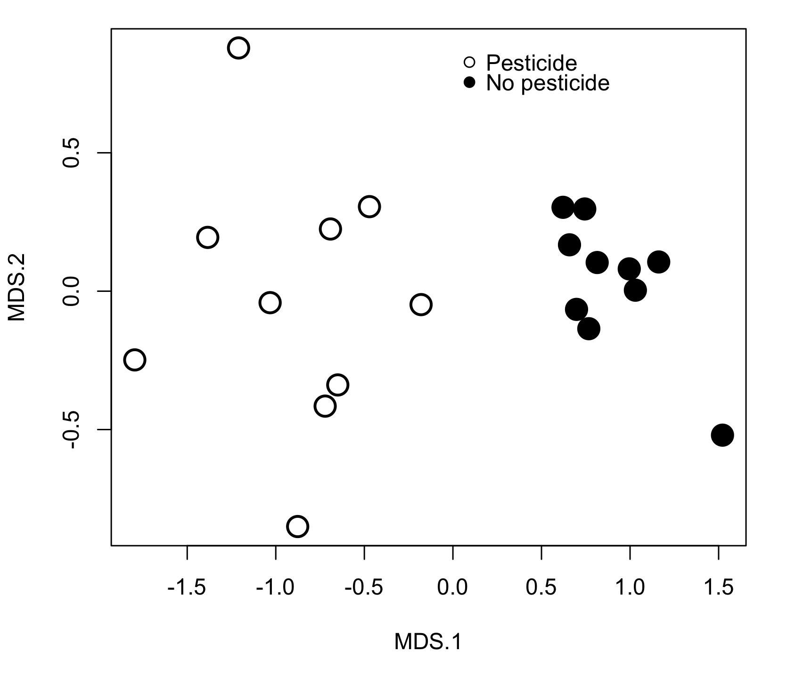
It seems clear from this plot that the 2 different treatments are clustering away from each other. The pesticide treatments are all clustered over to the left, while the no pesticide treatments are all clustered to the right. It would therefore appear that the 2 treatments are significantly different from each other.

To formally test for differences, we use the “adonis” command, it functions like “aov” with respect to 1-way vs. multiway, interactions etc. The only difference is that we’re using 2 data sets, “spp” to get the abundances, and “comm” to get the treatments….

adonis(spp~treatment,data=comm,permutations=999)

Call:
adonis(formula = spp ~ treatment, data = comm, permutations = 999)

Df SumsOfSqs MeanSqs F.Model R2 Pr(>F)
treatment 1 2.4086 2.40862 20.628 0.53402 0.001 ***
Residuals 18 2.1017 0.11676 0.46598
Total 19 4.5104 1.00000

We can see from the output that the 2 differences do differ from each other.

This sort of analysis has several advantages over MANOVA. Firstly, it makes far fewer assumptions of the data and so is much more robust to things like a lack of normality in the data. Also, the graphs make discussions of the results much easier, and actually convey a lot of information quickly and easily.

We have only just scratched the surface of NMDS here. If you want to delve deeper into it, there are many books available, and this is an analytical technique increasing in popularity.

TASK
The dataset “highways.csv” contains abundances of different stream species obtained upstream and downstream of bridges, for 7 highways and 7 local roads. We’re interested in whether or not run-off from roads affects species composition, we hypothesis that communities upstream of bridges will be different from those downstream of bridges, and that the effect will be different depending on the size of the road.

Download the dataset, analyse using both a MANOVA and multidimensional scaling. Do the results mean we can keep our hypothesis? Produce a plot showing the results (think, there may be multiple ways to do this!)

